MANUAL OF MARKER METHODS
FOR THE
STUDY OF MICROBIAL ECOLOGY

SECTION I. Serological Methods
SECTION II. Antibiotic Resistance Markers
SECTION III. Bacteriophage Typing

Edited by B. B. Bohlool & E. L. Schmidt

NOTE: This is the FIRST DRAFT of a manual designed
for Training Workshops.

Please do not cite this source directly.
Autecology, one of the subdisciplines of ecology, is concerned with the study of specific organisms or species (i.e., Deer, Wolf, Sagebrush, Rhizobium japonicum, etc., etc.) in their natural environments. The biologist studying the ecology of specific animals or plants has ample opportunity to use the autecological approach, since it is relatively easy for him to recognize his subject in situ.
This highly productive branch of classical ecology, however, has been virtually closed to the microbial ecologist. This is mainly due to the small size of microorganisms, their nondescript morphology, and the extreme complexity of their microenvironments.
Looking under the microscope at a small portion of the natural environment can reveal fascinating interrelationships between microorganisms and their microhabitat. But it is virtually impossible to identify the various species of the microbial assembledges in situ.
The conventional plate culture method, due to its ease and simplicity, has become the most widely used technique in microbial ecology. However, it supplies indirect, artificial, and often erroneous information about the actual conditions in nature.
Though microorganisms are nondescript in morphology, they do have unique chemical, physiological and genetic features which can be used to identify genera, species, and even strains of a particular microorganism. Such features as antigenic characteristics, bacteriophage susceptibility and antibiotic resistance have been used in ecological studies as markers for the identification of specific microorganisms.
In this manual we will detail three serological techniques, immunofluorescence, immunodiffusion and the enzyme-linked immunosorbent assay (ELISA), all of which are based on the antigenic uniqueness of microorganisms. In a separate section, we will also cover the essentials of the methodologies for the use of antibiotic-resistance markers, and bacteriophage typing.
The protocols given in this manual are based on personal experiences of the authors with the Rhizobiwn japonicum system. However, most of the procedures described are applicable to other systems. For specific applications you are to refer to the list of references.

I. Serological Techniques in Microbial Ecology
Chapter 1. Immunization Procedures
Chapter 2. Immunofluorescence (IF)
Chapter 3. Enzymes-Linked Immunosorbent Assay (ELISA)
Chapter 4. Immunodiffusion (ID)

By: B. B. Bohlool
E. L. Schmidt
S. N. May

CHAPTER ONE : Immunization Procedures for Production
Of Specific Antisera
CHAPTER ONE
IMMUNIZATION PROCEDURES

One of the best species available for antibody production is the rabbit. This is primarily because high antibody titers can be achieved and maintained in them. In addition, they are easy to obtain, are docile, and are relatively inexpensive. The route of injection varies depending upon the antigen preparation. Agglutination, immunofluorescence (IF), and the enzyme-linked immunosorbent assay (ELISA) deal with the particulate and structural components of the bacterial cell (somatic antigens). The intravenous (IV) route is the one of choice for these preparations and results in a rapid antibody response. However, it is not sustained over a long period. Therefore, to maintain the response, the subcutaneous (SC) route is used for booster injections. Immunodiffusion relies on soluble or solubilizable antigens which usually stimulate a poor antibody response. Therefore, the preferred route of injection is one which can accommodate the use of adjuvant, e.g. the intrafootpad (IF) or the intramuscular (IM).
For economical reasons and also to conserve time, each rabbit can be injected first with a somatic antigen preparation of a bacterial strain (IF, ELISA, agglutination). After sufficient quantities of this antiserum have been obtained, the same rabbit can then be injected with soluble antigens of the same bacterial strain to obtain antisera for immunodiffusion studies.
Somatic Antigen Procedure
(Agglutination, IF, and ELISA)

Material Needed:
4-10 day old shake flask cultures grown in Yeast Extract Mannitol
(see appendix)
.85% saline which has been filtered through a .45 µm membrane filter
Young adult female rabbits
1:100 merthiolate in water, pH8.0. [(Thiomersal) B.D.H., Gallard- Schiesinger Chem. Mfg. Corp., Carle Place, N.Y.]
Freund's Complete Adjuvant (Difco)

I. Preparation of Antigen for Injection:
Cultures are grown in broth of yeast extract mannitol. Centrifuge 3-4 day-old shake flask cultures (fast-growing rhizobia) or 7-10 day-old cultures (slow-growing rhizobia). Resuspend cells in membrane filtered saline. Centrifuge cells and resuspend in filtered saline. Repeat this washing procedure two more times and resuspend cells in enough filtered saline to give a final suspension of 1 x 10⁹ cells/ml. This can be estimated by reading the optical density of the suspension on a spectrophotometer. An optical density of .45 (A₆₀₀) is approximately equal to 1 x 10⁹ cells/ml. Heat the suspension in a boiling water bath for 1 hour to inactivate flagella and other protein antigens. Add merthiolate(to achieve a final concentration of 1:10,000) as a preservation and keep in the cold (4°C) until use.
II. Preimmune serum:
Bleed each rabbit through the marginal ear vein prior to the first injection. Only 2-3 ml from each rabbit is required. Allow the blood to clot at room temperature for one hour. Separate the clot from the wall of the tube by going around the clot with a wooden applicator stick. Separate the serum from the clot by storing at 4°C overnight. Pour the serum into a centrifuge tube and clarify further by mild centrifugation (4000 x g for 10 minutes). Add merthiolate (1:10,000) to this preimmune serum and freeze (-20°C) until needed.
III. Preparation of Antibody:
Use the above antigen suspension to immunize young-adult female rabbits, according to the following schedule: (a different schedule may be required for bacteria other than rhizobia).

Day Route of Injection Form of Antigen
1 Intravenous (IV) 0.5 ml antigen
Subcutaneous (SC) 1.0 ml antigen
Intramuscular (IM) 1.0 ml antigen/adjuvant
mixture (see appendix)
2 IV 1.0 ml antigen
3 IV 1.5 ml antigen
4-6 REST none
7 IV 1.5 ml antigen
8 IV 2.0 ml antigen
9 IV 2.0 ml antigen

Allow the rabbits to rest for one week. After the rest, test bleed through the marginal ear vein. Test the collected serum for agglutination titer using the tube-agglutination method (see appendix). Rabbits exhibiting sufficiently high titers (not less than 1280) are starved for food for 24 hours and then bled for 30-40 ml by cardiac puncture. Each rabbit is given an intraperitoneal injection of sterile membrane filtered physiological saline to replace body fluids. The amount to be injected should approximately equal the amount of blood which was drawn. The high antibody titer in the rabbits can be maintained for several months by injecting them subcutaneously every 2 weeks with 2 ml of antigen. Always allow the rabbits to rest 1 week after injection before bleeding them. Rabbits with titers less than 1280 should not be bled and should be given 2 ml intramuscularly or 2 ml subcutaneously. Test bleed these rabbits after another week and check titer again.
Allow the blood to clot and harvest the serum as described for "preimmune serum" above. Add merthiolate to each tube and freeze (-20ºC) until ready to use.

Soluble Antigen Procedure
(Gel-immunodiffusion)
Materials Needed:
4-10 day-old cells grown on Bishop's defined Medium (see appendix)
.85% membrane filtered saline
Young adult female rabbits
Freund's incomplete Adjuvant
I. Preparation of Antigen:
Cells for this procedure should be grown on a defined medium (see appendix, Bishop's) to avoid contamination with constituents of yeast extract, peptone, etc. Harvest cells from the surface of 4-10 day-old agar cultures in membrane-filtered saline and adjust cell density to 1 x 10⁹ cells/ml. (To obtain a large number of cells, grow the bacteria on agar flats). Add merthiolate (1:10,000) and store at 4°C until use.
II. Preimmune Serum:
If the same rabbits were already used for injecting particulate antigens, this step has already been accomplished. If the rabbits have not previously been injected, obtain preimmune serum as described above.
III. Antibody preparation:
When preparing antibodies against soluble antigens, the best routes of injection are the intrafootpad (FP), the intramuscular (IM), or the subcutaneous (SC).
Use the antigen preparation to immunize young-adult female rabbits according to the following schedule:

Day Route of Injection Form of Antigen
1 FP (optional) 0.5 ml Ant./Adj.
IM 1.0 ml Ant./Adj.
15 SC 2.0 ml without Adjuvant
Note: Never give Ant./Adj. mixture IV.

Allow the rabbits to rest for 10 days. Test bleed from the marginal ear vein. Harvest the serum as before. If strong multiple bands develop in immunodiffusion plates (Chapter 4), starve rabbits for 24 hours and bleed by cardiac puncture. Remember to give each rabbit an intraperitoneal injection of sterile membrane-filtered physiological saline to replace body fluids. Harvest serum as before, distribute into small volumes (1-2 ml) and store at -20°C.
High titers can be maintained in rabbits by subcutaneous injections of 2 ml of antigen every 2 weeks. Allow rabbits to rest at least 1 week after an injection before bleeding them again.

CHAPTER TWO : The Immunofluorescence Approach
In Microbial Ecology

CHAPTER TWO
IMMUNOFLUORESCENCE

The fluorescent antibody technique provides a means for the visualization of the antigen-antibody complex. This is accomplished by coupling the antibody to a fluorochrome (a fluorescent dye), reacting the fluorescent antibody with the microorganism of interest and observing the fluorescent complex under a fluorescent microscope. The technique is endowed with the sensitivity and specificity of immunological reactions and the precision of microscopy. It, alone among techniques, has the potential of detecting and identifying a specific microorganism simultaneously. Several applications of this technique in microbial ecology and public health microbiology are listed in Table 1.
Fluorescent antibody staining of soil contact (buried) slides offers a potential approach to the in situ study of the interrelationships of microorganisms within their natural ecological niches.

Materials Needed:
Fractionation:
3.9 M (NH₄)₂SO₄
.85% NaCl
Dialysis tubing₂
Saturated BaCl
Conjugation:
Biuret Reagent (see Appendix III)
.1 M Sodium phosphate (pH 9)
.1 M Sodium phosphate buffer (pH 8)
Fluorescein isothiocyanate (FITC, Isomer I), (BBL, Cockeysville, Md )
.1 N NaOH
Merthiolate (1%)
G-25 Sephadex (coarse)
Phosphate-buffered Saline, pH 7.2 (PBS)
Testing:
Fresh broth cultures) of the organisms) of interest
IF microscope
non-fluorescent mounting fluid (Difco) or a 1:9 PBS :glycerol solution, pH 7.2
PBS

I. Fractionation of Serum Globulins
To a measured amount (i.e., 15 ml) of undiluated serum add an equal volume of cold 3.9 M ammonium sulfate. Keep serum cold (on crushed ice) and slowly add ammonium sulfate dropwise with constant stirring. This is easiest to accomplish if the serum is placed in a centrifuge tube in a beaker containing crushed ice. Allow the cloudy mixture to stand at least 1 hr. at 4°C and separate globulins by centrifugation (10,000 g for 30 minutes). Decant supernatant fluid and dissolve the precipitate in enough water (approx. 13 ml) to give the assigned volume of the serum. Repeat ammonium sulfate precipitation, but without the 1 hr incubation. Three precipitations is usually sufficient to render the globulins completely white and free of hemoglobin. Dissolve the final precipitate in a minimum volume of saline and dialyze against 0.85% NaCl, using frequent changes of saline, until sulfate is no longer detectable in the dialysate. The presence of sulfate can be determined by the addition of equal volumes of dialysate and saturated barium chloride. If the mixture does not become cloudy, the dialysate can be considered free of sulfate and dialysis complete.
II. Preparation of Fluorescent Antibody (FA)
Determine the protein concentration of the solution inside the dialysis tubing by the Biuret method (see appendix) and adjust to 1.0% (10 mg protein/ml) by the addition of 0.85% saline.
Add 4 ml of 0.1 M sodium phosphate buffer (pH 9) to 10 ml of the 1% globulin solution, follow by adding 4 ml of 0.1 M sodium phosphate buffer (pH 8) that contains sufficient freshly dissolved Fluorescein isothiocyanate (FITC) (BBL) to provide 0.05 mg FITC/mg of protein (5.0 mg in this case). Adjust pH to 9.5 with 0.1 N NaOH and make volume up to 20 ml with 0.85% saline. Don't raise the pH above 9.5. Add merthiolate (1:10,000) as a preservative and allow conjugation to proceed for 6 hours. Conjugation is best accomplished in a small beaker or vial with constant stirring. Cover with aluminum foil and allow conjugation to proceed at room temperature.
Separate the conjugated fluorescent antibody from unreacted FITC by Sephadex (G-25, coarse) chromotography (alternatively, the preparation can be dialyzed against PBS-pH 7.2 until no further color is detected in the dialysate). Allow the FA to sit overnight in the cold (4ºC). Centrifuge the FA to remove any cloudy material and filter the supernatant through a .45 µm filter to further remove any particulate material. Test the FA as described in the following section. If satisfactory, distribute the FA in small volumes (1 ml) in screw cap tubes and store in the freezer (-20°C) until use. Cryotubes (Vangard International, Inc. Neptune, N.J.) with a small capacity (1.2 cc) are extremely suitable for this purpose.
III. Initial Testing of FA
The FA should be tested against its homologous antigen in order to insure its quality. In addition, the optimum working dilution of the FA should be assessed. Make at least 6 smears from fresh broth cultures) of the homologous organism, air dry, heat fix and cover the smear with a few drops of Rhodamine isothiocyanate gelatin conjugate (Bohlool and Schmidt, 1968) (optional, but if available, this improves background; see Appendix). Make two-fold serial dilutions of the FA to a final dilution of 1:32. Test each dilution in the following manner:
(1) Cover each smear with a drop of a particular dilution of the FA.
(2) Allow staining to proceed for 20 minutes in a moist chamber
(a petri dish containing a moistened piece of filter paper, inverted over the slides is adequate for this purpose).
(3) Remove excess FA by washing in PBS for 15 minutes. This is best accomplished by first rinsing off the FA with about 0.5 ml of PBS, then placing the slide in a slide staining dish containing PBS.
(4) Dip each slide in distilled water, air dry and mount in nonfluorescent mounting fluid.
(5) Observe each slide on a fluorescent microscope equipped with an HBO-200 or HBO-50 mercury vapor light source (OSRAM), with the FITC filter pack. The 12v quartz-halogen light sources available from most microscope manufacturers provide an excellent alternative to the more conventional UV light sources. They supply steady and stable light, and are cooler, less expensive and often longer lasting.
IV. Controls
Before a new FA can be used in ecological studies it must strain its homologous antigen brightly. In addition, many control checks are necessary. The specificity of the FA must be tested; thus, other related strains should be tested to insure that the FA is strain specific. If the FA is to be used to identify the organism of interest in a complex environment such as the soil, the FA should be tested against non-related soil microorganisms. Controls are detailed in Table 2.
V. Detection of rhizobia in nodules
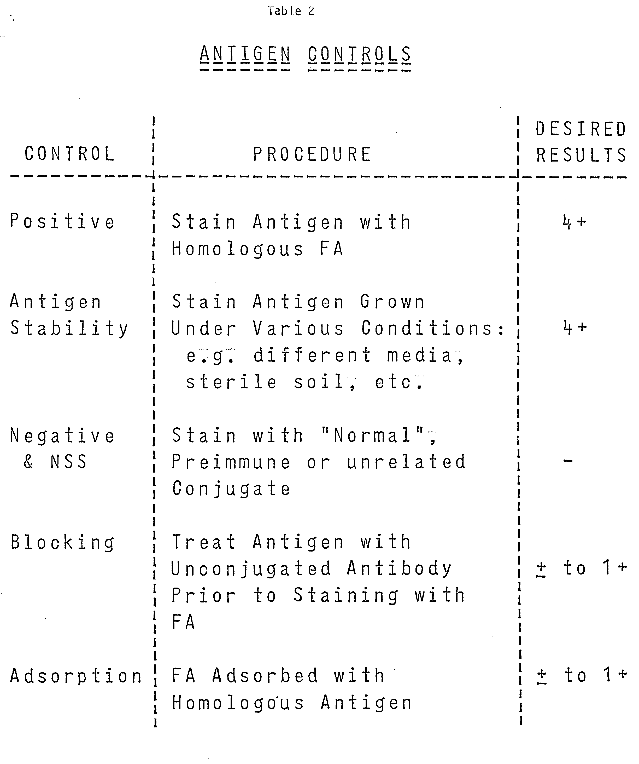
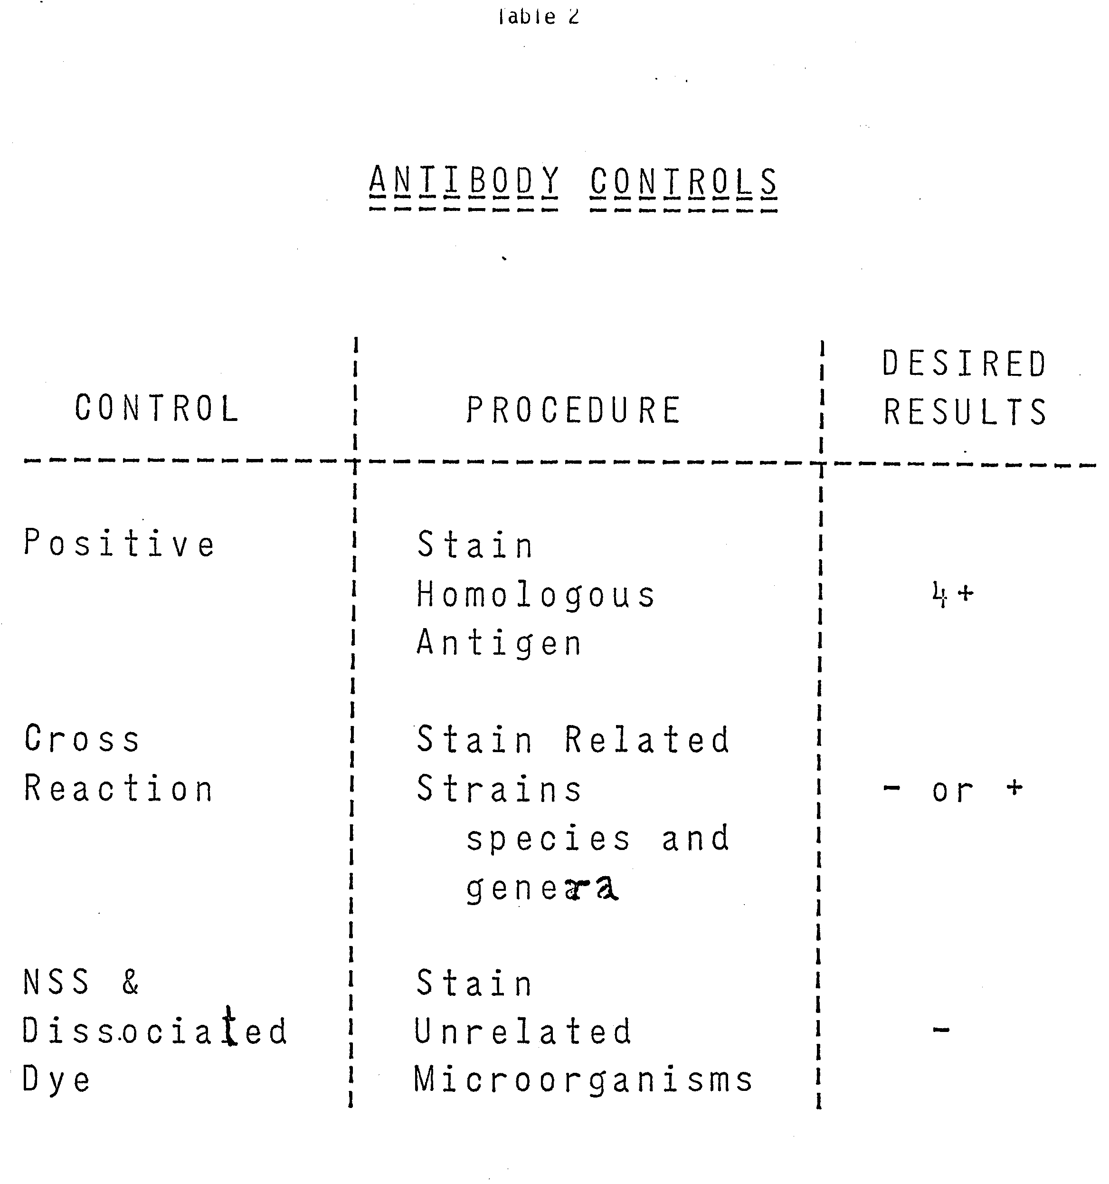
Legume Nodules: Immunofluorescence can be used to identify the bacteria that form the nodules on roots of leguminous plants. The nodule tissue can either be sectioned of homogenized for staining. We have found the following methods to be quite suitable:
(1) Roots are washed in distilled water containing 0.1% Tween-80, rinsed four times, and surface sterilized in 0.1% acidified HgCl₂ for 2 minutes. Remove nodules with alcohol-flamed forceps and touch each nodule to the surface of glass-slides (as many as needed--if two FA's are to be tested against the nodule smear, 2-4 slides should be prepared). As many as 12 nodules can be smeared onto the same slide, if careful. Smears are air dried, heat-fixed, and 1 drop of RhITC-conjugate is applied to each smear. Allow the RhITC to dry as a film in a drying oven (60ºC). After cooling the slides, proceed with FA staining according to the protocol above.
(2) Roots are washed as above. Each nodule is crushed in a drop of sterile water. T his homogenate is then used to make smears on glass slides as above. Proceed with FA staining.
VI. Special Applications
A. Staining of Soil Contact (buried) Slides
Rossi-Cholodney soil contact slides could be stained with the fluorescent antibody. However, in most soils, it is necessary to treat the slide with gelatin-rhodamine conjugate (Bohlool & Schmidt, 1968) to prevent the absorption of FA to soil particles on the slides, and also to provide a suitable dim orange (rhodamine) background against which the apple green (FITC) bacteria could be observed more clearly.
Bury slides in contact with soil for various lengths of time, either in flasks or in the field. Shake off the excess soil, air dry and heat-fix. Add enough of the gelatin-rhodamine solution (See Table 2 for-the preparation of the gelatin solution) to cover the surface of the slide (about 0.5-1.0 ml), and allow to dry as a film in a 60°C drying-oven. After cooling, cover the surface with an appropriate dilution of the FA (depending on the strength of the FA) and stain in a moist chamber for 30-45 minutes. Wash as above. Air-dried slides can then be coverslipped with FA mounting fluid and observed as before.
B. Quantitative estimation of numbers of bacteria in Natural Samples
Enumeration of bacteria in water samples presents no special difficulties. An appropriate volume of the sample is filtered through a nonfluorescent black membrane filter and washed with o.9% saline. The rest of the staining procedure is the same as that for soil samples.
The Enumeration of bacteria in soil is complicated by the colloidal and particulate nature of the sample. The protocol for the removal of these fractions and the recovery of the specific bacteria is given in Table 3. For data concerning the efficiency of recovery by this method see Bohlool & Schmidt, 1973, and Schmidt, 1974 Kingsley & Bohlool, 1981.
C. Mycorrhizal Structures: Immunofluorescence has been successfully used for the identification of mycorrhizal endophytes. For details see Schmidt, et al, 1974.
REFERENCES*

(IMMUNOFLUORESCENCE)

Allen, E. and A. Kelman. 1977.
Immunofluorescent stain procedures for detection and identification of Erwinia carotovora var. atroseptica. Phytopatholooy 67:1305-1312.

Apel, W. A., P. R. Dug an, J. A. Filppi and M. S. Rheins. 1976. Detection of Thiobacillus ferroxidans in acid mine by indirect fluorescent antibody staining Appl. Environ. Microbiol. 32:159-165.

Auger, J. G. and T. A. Shalla. 1975.
The use of fluorescent antibodies for detection of Pierces disease bacteria in grapevines and insect vectors. Phtopathology 65:493-494.

Bettelheim, K. A., J. F. Gordon and J. Taylor. 1965.
The detection of a strain of Chronobacterium lividum in the tissue of certain leaf-notlulated planes by immunofluorescence technique. J. Gen. Microbiol. 54:177-154.

Belser, L. and E. L. Schmidt. 1978.
Immunofluorescent serotypes of Nitrobacter. (personal cormmication)

Bohlool, B. B., and T. D. Brock. 1974.
Immunofluorescence approach to the study of the ecology of Thermoplasma acidophilum in coal refuse material. Appl. Microbiol. 25:1.1-15.

Bohlool, B. B., and T. D. Brook. 1974.
Population ecology of Sulfolabus acidocaldarius. II. Immunoecological studies. Arch. Microbiol. 97:181-194.

Bohlool, B. B., and E. L. Schmidt. 1968.
Nonspecific staining: its control in immunofluorescence examination of soil. Science 162:1012-1014.

Bohlool, B. B., and E. L. Schmidt. 1970.
Immunofluorescent detection of Rhizobium japonicum in soils. Soil Science 110:229-236.

Bohlool, B. B., and E. L. Schmidt. 1973.
A fluorescent antibody technique for determination of growth rate's of bacteria in soil. In T. Rosswall (ed.); Modern methods in the study of microbial ecology. Bull. Ecol. Res. Commun. (Stockholm) 17:336-338.

Bohlool, B. B., and E, L. Schmidt. 1973.
Persistence and competition aspects of Rhizobium japonicum observed in soil by immunofluorescence microscopy. Proc. Soil Soc. American 37:551-564.

* For an update see:Bohlool, B.B., and Schmidt, E. L. 1980. The Immunofluorescence Approach in Microbial Ecology. In "Advances in Microbial Ecology", Vol.4, Edited by M. Alexander. Plenum Publishing Co.

Bohlool, B. B. 1975.
Occurrence of Sulfolobus acidocoldarius, an extremely thermophilic acidophilic bacterium, in New Zealand hot springs: isolation and immunofluorescence characterization. Arch. Microbiol. 106:171-174.

Cherry, W. B., J. B. Hanks, B. M. Thomason, A. M. Murlin, J. W. Biddle, and J. M. Croom. 1972.
Salmonellae as an index of pollution of surface waters. Appl. Microbiol. 24 (3):334-

Diem, H. G., G. Godbillon, and E. L. Schmidt. 1977.
Application of the fluorescent antibody technique to tile study of an isolate of Beijerinekia in soil. Can. J. MIcrobiol. 23:161-165.

Danielsson, D., and G. Lauren. 1965.
A membrane filter method for the demonstration of bacteria by the fluorescent antibody technique. Acta Path. and Microbiol. Scandinav. 63:604-608.

Deville, R. R., and Y. T. Tchan. 1970.
Etude quantitative de la population Azotobacterienne du sol par la methode d'immunofluorescence. Ann Inst. Pasteur 119:492-497.

Eren, J., and D. Pramer. 1966.
Application of immunofluorescent staining, to studies of the ecology of soil microorganisms. Soil Science 101:39-45.

Fliermans, C. B., B. B. Bohlool, and E. L. Schmidt. 1974. Autecological study of the chemoautotroph Nitrobacter by immunofluorescence. Appl. MIcrobiol. 27:124-129.

Fliermans, C. B., and E. L. Schmidt. 1975.
Autoradiography and immunofluorescence combined for autecological study of single cell activity with Nitrobacter as a model system. Appl. MIcrobiol. 30:676-684.

Fliermans, C. B., and E. L. Schmidt. 1977.
Immunofluorescence for autecological study of a unicellular bluegreen alga. J. Phycol. 13:364-368.

Fliermans, C. B., and E. L. Schmidt. 1977.
Nitrobacter in Mammoth Cave. Int. J. Speleol. 9:1-19.

Guthrie, R. K. and D. J. Reeder. 1969.
Membrane filter-fluorescent-antibody Method for detection and enumeration of bacteria in water.

Garcia, M. M., and K. A. McKay. 1969.
On the growth and survival of Clostridum septican in soil. J. Appl. Bact. 32:362-370.

Garcia, M. M., D. H. Neil, and K. A. McKay. 1971.
Application of immunofluorescence to studies on the ecology of Sphaerophorus necrophorus. Appl, Microbiol. 21:809-814.

Henry, R. A., R. C. Johnson, B. B. Bohlool and E. L. Schmidt. 1971. Detection of Leptospira in soil and mater by immunofluorescent staining. Appl. Microbiol. 21:953-956.

Hill, I. R., and T. R. G. Gray. 1967.
Application of the fluorescent antibody technique to an ecological study of bacteria in soil. J. Bacteriol. 93:1888-1896.

Hobson, P. N., and S. 0., Mann. 1957.
Some studies on the identification of rumen bacteria with fluorescent antibody. J. Gen. Microbiol. 16:463-471.

Jones, D. G., and P. E. Russell. 1972.
The application of immunofluorescence techniques to host plant/nodule bacteria selectivity experiments using Trifolium repens. Soil Biol. Biochem. 4:277-282.

Lindemann, W. C., E. L. Schmidt, and G. E. Ham. 1974.
Evidence for double infection within soybean nodules. Soil Science 118(4): 274-279.

Mosser, J. L., B. B. Bohlool, and T. D. Brock. 1974.
Growth rates of Subfolobus acidocaldarius in nature. J. Bact. 118:1075-1081.

Paton, A. M. 1974.
The adaption of the immunofluorescence technique for use in bacteriological investigations of plant tissue. J. Appl. Bacteriol. 27:237-242.

Pugsley, A. P., and L. M. Evison. 1974.
Immunofluorescence as a method for the detection of Escherichia coli in water. Can. J. Microbiol. 20:1457-1463.

Puglsey, A. P. and L. M. Evison. 1975.
A fluorescent antibody technique for the enumeration of faecal streptococci in water. J. Appl. Bact. 38:63-65.

Reed, W. M., and P. R. Dugan. 1977.
Distribution of Methylomonas methanica and Methylosinus trichosporium in Cleveland Harbor as determined by an indirect fluorescent antibody-membrane filter technique. Appl. Environ. Microbiol. 35:422-430.

Rennie, R. J., and E. L. Schmidt. 1977.
Immunofluorescence studies of Nitrobacter populations in soils. Can. J. Microbiol. 23:1011-1017.

Schaad, N. W. 1978.
Use of direct and indirect irmunofluorescence tests for identification of Xanthomonas campestris. Phytopath. 68:249-252.

Schmidt, E. L., and R. 0. Bankole. 1962.
Detection of Asperzillus flavus in soil by immunofluorescent staining. Science 136:776-777

Schmidt, E. L. and R. 0. Bankole. 1963.
The use of fluorescent antibody with the buried slide technique. In: Soil Organisms, ed. J. Doeksen and Van Der Drift. North Holland Publ. Co. Amsterdam, 197-204.

Schmidt, E. L. and R. 0. Bankole. 1965.
Specificity of immunofluorescent staining for study of Asperzillus flavus in soil. Appl. Microbiol. 13:673-679.

Schmidt, E. L., R. 0. Bankole and B. B. Bohlool. 1968.
Fluorescent antibody approach to the study of rhizobia in soil. J. Bacteriol. 95:1987-1992.

Schmidt, E. L. 1973.
Fluorescent antibody technique for the study of Microbiol ecology. In T. Rosswall (ed.), Modern methods in the study of Microbiol ecology.

Schmidt, E. L. 1974.
Quantitative autecological study of microorganisms in soil by immunofluorescence. Soil Sci. 118:141-149.

Schmidt, E. L., J. A. Biesbrock, B. B. Bohlool, and D. H. Marx. 1974. Study of Mycorrhizae by means of fluorescent antibody. Can. J. Microbiol. 20(2):137-139.

Siala, A., and T. R. G. Gray. 1974.
Populations of spore-forming bacteria in an acid forest soil, with special reference to Bacillus subtilis. J. Gen. Microbiol. 31:183-190.

Strayer, R. F. and J. M. Tiedje. 1978.
Application of the fluorescent-antibody technique to the study of a methanogenic bacterium in lake sediments. Appl. Environ. Microbiol. 35:192-198.

Tchan, Y. T. and R. R. Deville. 1970.
L'application de l'immunofluorescence a l'etude des Azotobacter du sol. Ann. Inst. Pasteur 118:665-673.

Trinick, M. J. 1969.
Identification of legume nodule bacteroids by the fluorescent antibody reaction. J. Appl. Bacteriol. 32:181-186.

Warnock. D. W. 1971.
Assay of fungal mycelium in grains of barley, including the use of the fluorescent antibody technique for individual fungal species. J. Gen. Microbiol 67:197-205.

Warnock, D. W. 1973.
Use of immunofluorescence to detect mycelium of Alternaria, Asperizillus, and Penicilluim in barley grains. Trans. Br. Mycol. Soc. 61(3):547-552.
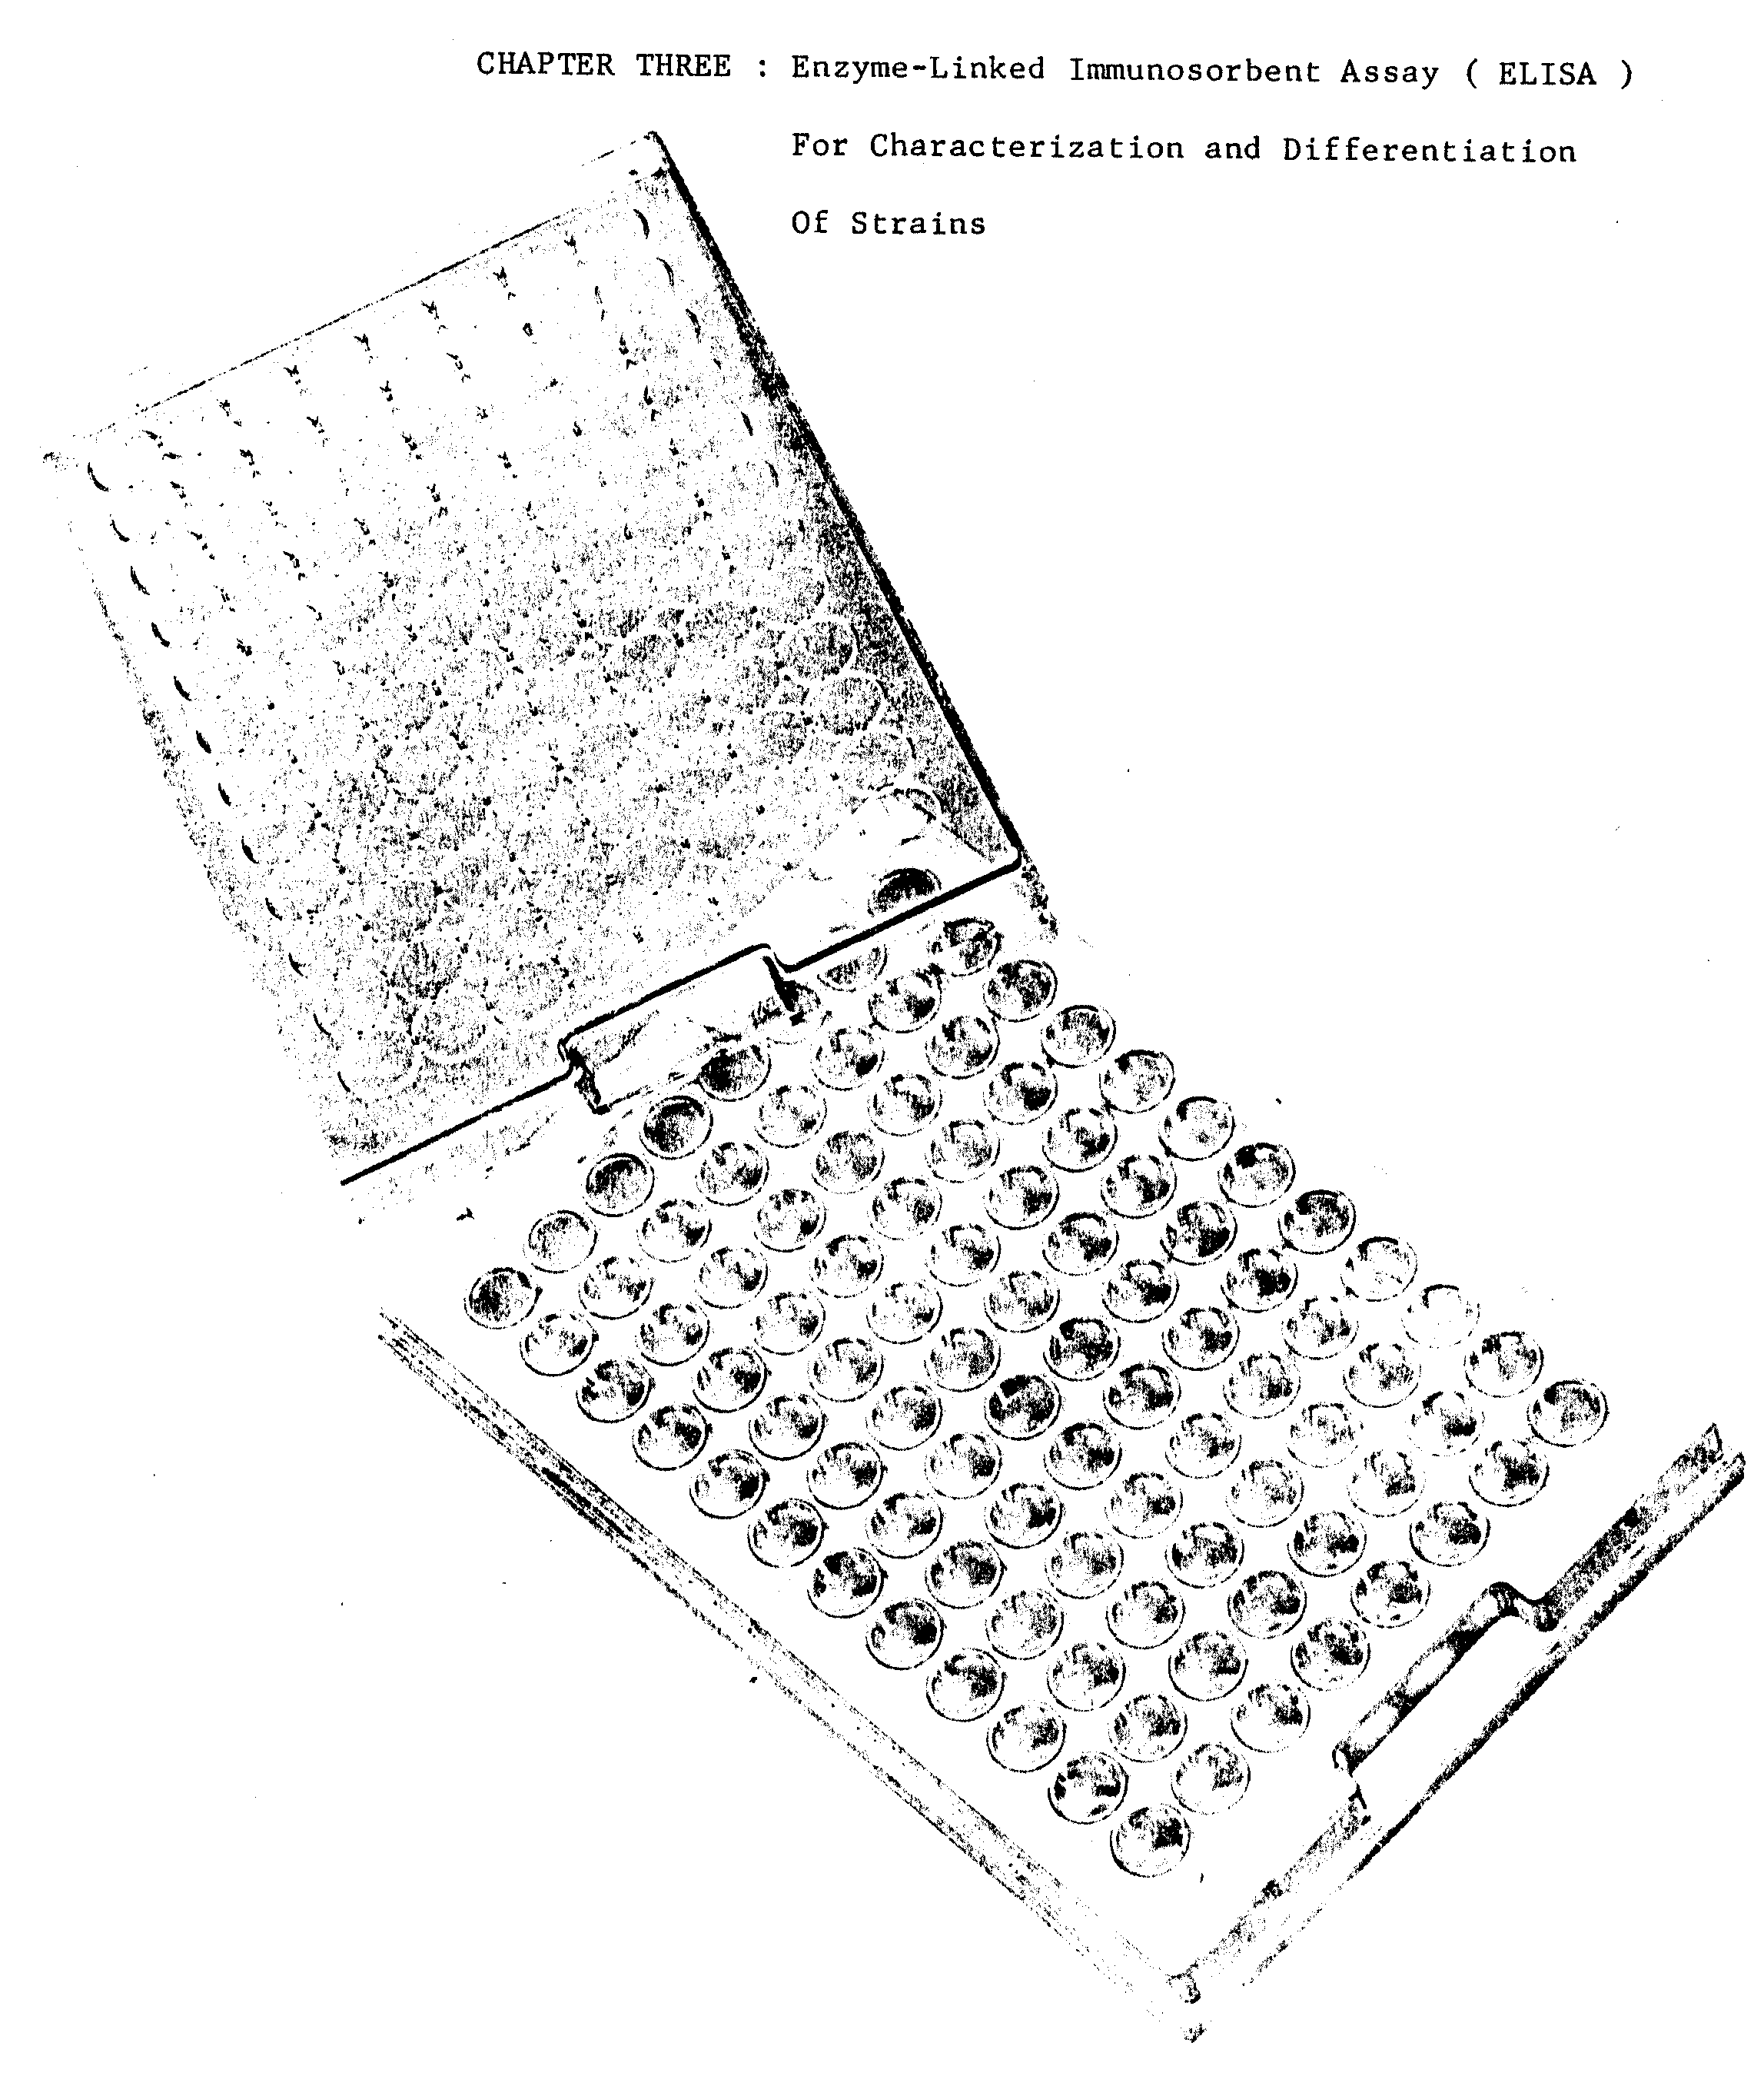
Chapter 3

Enzyme-linked lmmunosorbent Assay
(ELISA)

A. Direct Method
The ELISA technique provides a colorimetric method for the identification of bacteria. A strain specific antiserum is conjugated to an enzyme such as alkaline phosphatase or peroxidase. Bacteria are coated with the enzyme-labelled antibody. After a period of incubation and subsequent washing, a chromogenic substrate is applied to the antibody treated smear. The formation of an antigen-antibody complex is detected visually or spectrophotometrically. The ELISA is endowed with the specificity of antigen-antibody reactions and the sensitivity of enzyme-catalyzed reactions. It requires very small amounts of antiserum and no microscopic equipment is necessary. For this technique a highly purified globulin preparation is required. Therefore, two fractionation steps are presented: Sodium sulfate precipitation, followed by further purification through a G-200 Sephadex Column. In addition, an alternate purification method is presented with which we have had good results.
Materials needed
Fractionation:
Antiserum
Solid Na₂SO₄
.85% Saline
Phosphatase Buffered Saline, pH 7.4 (PBS) (see appendix) G-200 Sephadex
Biuret Reagents (see appendix)
Conjugation:
Alkaline phosphatase Type VII from calf-bovine intestine, 5 mg (Sigma Chemical Co., St. Louis, Mo.)
25% glutaraldehyde (Research Industries, LADD)
0.05 M Tris buffer, pH 8.0 (see appendix)
Oval bumin (Grade III, Sigma Chemical Co., St. Louis, Mo.)
0.02% NaN₃.
ELISA test:
PBS-Tween 24, containing 0.001 M MgCl₂ (see appendix)
Fresh broth cultures (homologous and heterologous) adjusted to a turbidity of 0.45 at a wavelength of 600 nm
Note: Cultures must be adjusted to the same turbidity.
5 mg/ml Bovine gamma globulin (BGG) (Fraction II, Pentex Biochemicals, Kankakee, III.)
Microtiter plates with a "U" bottom well (Dynatech Laboratories Inc., Alexandria, Va.)
p-nitrophenyl-phosphate, 1 mg/ml (Sigma Chemical Co., St. Louis, Mo.)
0.05 M Na₂CO₃ (pH 9.8)
3 M NaOH
0.2 M NaOH

I.A. Fractionation of Serum Globulins
To a measured volume of serum (10 ml) on a magnetic stirrer at room temperature, slowly add 14% solid Na₂SO₄ (1.4 g in this case). Centrifuge at 3000 x g for 10 minutes and discard the supernatant. Resuspend the precipitate in enough saline to give half the original volume of the serum (5 ml). Slowly add 12% solid Na₂SO₄ (0.6 g). Centrifuge and resuspend in saline (5 ml). Repeat this procedure one more time. Resuspend the final precipitate in saline (5 ml) and transfer to a dialysis sac. Dialyze at 4ºC against phosphate-buffered saline (PBS), pH 7.4. After several changes of PBS, determine the protein concentration of the globulin solution inside the dialysis tubing by either the Biuret Method or the 280/260 method (see appendix). Adjust the protein concentration to 10 mg protein/ml by diluting the globulin with saline. To obtain a more purified globulin solution, pass 1 ml of globulin through a G-200 Sephadex column (1.5 cm x 95 cm) in borate buffer (see appendix). Elute with borate buffer and collect 1.5 ml fractions. Collect fractions 1-100. Fraction A (lgM) will usually be in fractions 35-40 and Fraction B (lgG) in fractions 50-60. Read all fractions at 280 nm on a suitable spectrophotometer. Determine the protein concentration by using the following formula:
Extinction coefficient of 14 = 10 mg protein/m1
Example: if the optical density (OD) of a fraction is .7, then
Combine the fractions (Fraction A) with the highest protein concentration. This is best accomplished by plotting each fraction vs. O.D._{(280 nm)}. Combine the fractions which are in the peak of Fraction A. Do not add Fraction B portions to Fraction A. Concentrate the peak fractions by vacuum dialysis (see appendix). Pass Fraction A through the column again. Combine the peak fractions as before. Concentrate by vacuum dialysis. Dialyze the globulin extensively against PBS. Freeze the globulin in small quantities until use.

I.B. Alternate Purification Method: Affinity adsorption with homologous antigen.
Centrifuge fresh broth cultures of the homologous bacteria. Resuspend the pellet(s) in enough saline to obtain a final concentration of 1 x 10⁹ bacteria/ ml. Add merthiolate (1:10,000). You will need at least 20 ml of the bacterial suspension. Place 10 ml of the rabbit serum in a screw-cap test tube and place in a 56°C water bath for 30 minutes. This inactivates the complement in the serum. To the 10 ml of serum, add 5 ml of the homologous bacterial suspension.
Store at 4°C for 12 hours. Centrifuge at 10,000 x g for 10 minutes. Pour the supernatant serum into another centrifuge tube. Add 1 ml saline containing merthiolate (1:10,000) to the bacteria pellet and store this pellet at 4°C. This pellet contains not only bacteria, but also antibody specific for this particular organism. Add 5 ml of the bacterial suspension to the supernatant serum and again incubate this mixture for 12 hours at 4°C. Centrifuge as before and save both the supernatant serum and the pellet. Repeat this adsorption procedure at least two more times. After the last adsorption, and centrifugation, pour off the supernatant. Combine all the bacteria-antibody pellets and resuspend in enough saline plus merthiolate (1:10,000) to obtain a final volume of 7 ml. To this add 0.1 N HCL dropwise with stirring, until the mixture is pH 3.0. Allow the mixture to sit at room temperature for one hour. Lowering the pH to 3.0 releases the antibody from the surface of the bacteria. Centrifuge this mixture at 10,000 x g for 10 minutes. Save the supernatant and discard the pellet. The supernatant contains specific antibody. Add 0.1 N NaOH to the supernatant, dropwise with stirring, until a final PH of 7.0 is reached. Add saline plus merthiolate (1:10,000) to obtain a final volume of 10 ml (the original volume of the serum). Put this mixture in a centrifuge tube containing a magnetic stir bar. Place the centrifuge tube in a beaker of ice on a magnetic stirrer. Add 10 ml of 3.9 M (NH₄)₂SO₄ dropwise with stirring. Allow to sit at 4°C for 1 hour. Centrifuge at 10,000 x g for 20 minutes. Discard the supernatant. Redissolve the pellet in a minimum volume of distilled water (about 5 ml) and dialyze the mixture extensively against saline, until sulfate is no longer present in the dialysate. Determine the protein concentration of the mixture inside the dialysis bag by either the 280/260 method or the Biuret Method (see appendix). Freeze the globulin in small quantities until use.

II. Preparation of the enzyme-labelled antibody (conjugate) (Voller et al., 19).
Centrifuge the alkaline phosphatase suspension (EC 3.133.1, Type VII, Sigma Chemical Co., 5 mg). Discard the supernatant. Adjust the globulin solution to 2 mg protein/ml in PBS. Add 1 ml of this globulin solution to the enzyme pellet (5 mg of enzyme). Mix thoroughly at roam temperature. Dialyze at 4ºC with several changes of PBS. Add 25% glutaraldehyde to the enzyme-antibody mixture to give a final concentration for 0.2% glutaraldehyde (approximately .O1 ml). Allow conjugate to proceed for 1 to 2 h at room temperature. Dialyze at 4°C against several changes of PBS. Then dialyze the conjugate against several changes of Tris buffer (0.05 M, pH 8.0). Remove conjugate from the dialysis tube and add 1 ml of Tris buffer containing 1.0% oval bumin and 0.02% NaN₃ to the dialysis bag. Add this to the conjugate mixture. (This conserves any conjugate mixture which remained in the bag). Add enough Tris buffer containing 1.0% oval bumin and 0.02% NaN₃ to achieve a final volume of 4.0 ml. Store the concentrated stack conjugate in the dark at 4°C.

III. Determination of optimum conjugate concentration
Make dilutions of the stock conjugate in PBS-Tween 20. These dilutions should include 1:5, 1:10, 1:20, and 1:50 and should be prepared just prior to use. Further dilutions may be required, but the suggested dilutions should be tested initially. Proceed with the ELISA test in the following manner:
1. Fresh broth cultures are centrifuged and washed three times in distilled water. Suspensions of different strains (homologous and heterologous) must be adjusted to the same turbidity (A₆₀₀ = 0.45). Use a microtiter plate with 96 wells to perform the ELISA test. To each of the top 12 wells add 0.05 ml of cell suspension (homologous). Add 0.05 ml of the heterologous cell suspension to the second row of melts. The third row is a control and no cells are added.
2. Place the microtiter plate in a 60°C drying oven overnight.
3. Wash smears 2 times for 5 minutes with PBS-Tween 20 (PBST) containing 0.001 M MgCl₂ (see appendix). This is best accomplished by using a squeeze bottle to fill each well with PEST. Turn slide over to remove PBST and shake off any excess moisture.
4. Add 0.05 ml of bovine gamma globulin (BGG) (5 mg/ml) to each depression, and incubate in a moist chamber for 30 minutes.
5. Wash slides 3 times with PBST, and shake off excess moisture.
6. To duplicate wells add 0.05 ml of a dilution of the conjugate as shown below.
7. Incubate in a moist chamber for 1-2 h.
8. Wash 3 times with PEST as above.
9. Add 0.05 ml of p-nitrophenyl-phosphate (l mg/ml; Sigma Chemical Co.) in 0.05 M Na₂CO₃ (pH 9.8).
10. Reincubate in the moist chamber for 10 to 20 minutes until sufficient color develops (bright yellow) in the homologous system to be estimated visually and/or measured spectrophotometrically.
11. Add 0.05 ml of 3 M Na0H to stop the reaction and swirl the slide gently to mix. For quantitative measurements, immediately transfer the sample from each well to tubes containing 3 ml of 0.2 M NaOH. Read the tubes on a spectrophotometer at A₄₀₀. Compute from a standard curve the micromoles of nitrophenol released from the substrate.
12. The dilution of conjugate yielding the clearest results (most clearcut difference between homologous and heterologous system) is used in all future experiments. Remember to dilute the stock conjugate just prior to use, as it should always be stored in the concentrated form.

IV. Performing the ELISA test: Cultures and Nodules
Steps 1-9 from section III should be followed, except only the optimum dilution of conjugate needs to be used (see above). In doing the ELISA test, it is necessary to include on every microtiter plate both positive and negative controls for the antiserum used.
To identify Rhizobium strains in nodules, single nodules are boiled in distilled water to give a turbidity of A₆₀₀ = .45. Known standards are used as positive and negative controls and should have the same turbidity as the unknowns. Allow the nodule debris to settle; and decant the crude cell suspension. Make duplicate wells of each nodule supernatant and proceed with steps 1-9 from section III, using the optimum conjugate dilution which was previously-determined above on pure culture.

B. Indirect Method
The indirect ELISA involves the use of two antisera. It requires strainspecific rabbit antiserum and sheep or goat anti-rabbit globulin. The sheep anti-rabbit globulin is conjugated to alkaline phosphatase. If several strains are to be identified, the indirect method is preferable, as only one serum needs to be conjugated. However, this assay requires additional incubation and washing steps and is more tune consuming to perform than the direct method. Thus, the direct method is preferable when only 2 or 3 strains are to be identified.
TABLE 3 Protocol for immunofluorescence enumeration of
specific bacteria in soil (Based on Bohlool & Schmidt 1968)*

STEP PROCEDURE

1. Dispersion 100 ml of al/10 soil dilution is dispersed in a blender fox 3-5 minutes with 5 drops Tween 80 (Difco) and 1-2 drops antifoam AF71.

2. Flocculation Transfer dispersed soil suspension to a bottle containing 0.7 g of flocculant mixture (Ca(OH)₂:MgCo₃, 2:5). Shake vigorously by hand for 2 minutes; allow to settle 30-60 minutes.

3. Filtration Pass appropriate volume of supernatant (up to 20ml) through an Irgalan Black pretreated Nucleopore filter. Remove filter and place on a microscopes slide.

4. Staining Cover effective filter surface with 0.5 ml of gelatin-rhodamine conjugate. Bring to dryness at 50-60°C. Cover surface with about 0.5 ml of FA previously passed through a 0.45 µm filter and incubate for 20 minutes at room temperature under inverted Petri dish cover. Return membrane filter to filter assembly and wash excess FA through filter with at least 100 ml of membrane filtered saline.

5. Examination Place filter on microscope slide, add a drop of FA mounting fluid (Difco), and cover with no. 1 1/2 cover slip. Count reactive bacteria in at least 20 fields per filter (100 or more fields if numbers are very low) using incident light fluorescence microscopy.

6. Calculation Number/g = (N_{f} A D)/aV where: N_{f} is average number/microscope field; A is effective filtering area (cm²); D is dilution factor; a is area of microscope field in cm², and V is volume in ml of supernatant passed through filter.

*For a modification of this procedure see Kingley & Bohlool 1981. Appl. Environ. Microbiol. 42, 241-248.
Materials needed
Fractionation:
Antiserum
Solid Na₂SO₄
.85% Saline
Phosphate Buffered Saline, PH 7.4 (PBS) (see appendix)
G-200 Sephadex
Biuret Reagents (see appendix)
Conjugation:
Alkaline phosphatase Type VII from calf-bovine intestine, 5 mg (Sigma Chemical Co., St. Louis, Mo.)
25% glutaraldehyde (Research Industries, LADD)
0.05 M Tris buffer, pH 8.0 (see appendix)
Oval bumin (Grade III, Sigma Chemical Co., St. Louis, Mo.)
0.02% NaN₃
ELISA test:
PBS-Tween 20, containing 0.001 M MgCl₂ (see appendix)
Fresh broth cultures (homologous and heterologous) adjusted to a turbidity of 0.45 at a wavelength of 600 nm
Note: Cultures must be adjusted to the same turbidity.
5 mg/ml Bovine gamma globulin (BGG) (Fraction II, Pentex Biochemicals, Kankakee, III.)
p-nitrophenyl-phosphate, 1 mg/ml (Sigma Chemical Co., St. Louis, Mo.)
0.05 M Na₂CO₃ (pH 9.8)
3 M NaOH
0.2 M NaOH
Sheep or goat anti-rabbit serum or globulin

I. Fractionation of Serum Globulins
Rabbit antisera is fractionated as in the direct method. Sheep anti-rabbit serum, sheep anti-rabbit globulin, and conjugated sheep anti-rabbit globulin are available from commercial sources. If sheep anti-rabbit serum is used, it is fractionated as above. After fractionation and protein determination, the antisera can be frozen in small quantities.

II. Preparation of the enzyme-labelled antibody (conjugate)
The sheep anti-rabbit globulin (SARG), 1 ml of 2 mg/ml globulin in PBS, is conjugated to the alkaline phosphatase as above.

III. Determination of optimum rabbit antisera concentration and SARG-conjugate concentration
Make dilutions of the stock conjugate in PBS-Tween as described for the direct method. Dilutions of the rabbit globulin must also be made and tested the optimum working strength for the Rhizobium leguminosarum system was: 75 µg/ml of anti-rhizobial globulin and 18.6 µg/ml of SARG conjugate. Therefore, these dilutions or those very close to this should be tested first against pure cultures of both homologous and heterologous organisms. The initial test for dilution strength is carried out as follows:
1. Fresh broth cultures are centrifuged and washed three times in distilled water. Suspensions of different strains (homologous and heterologous) must be adjusted to the same turbidity (A₆₀₀ = 0.45). Use a glass concavity slide with 12 wells to perform the ELISA test. To each of the top 4 wells add 0.05 ml of cell suspension (homologous). Add 0.05 ml of the heterologous cell suspension to the middle row of wells. Spread the cells evenly over the bottom half surface of each well. The bottom row is a control and no cells are added. Two identical slides are required to test all four conjugate dilutions.
2. Dry the smears under warm air (a conventional hair dryer is satisfactory). Heat fix by moving each slide back and forth repeatedly for 20 seconds on a standard laboratory hot plate, set on low heat.
3. Wash smears 2 times with PBS-Tween 20 (PEST) containing 0.001 M MgCl₂. This is best accomplished by using a squeeze bottle to fill each well with PEST. Turn slide over to remove PBST and shake off any excess moisture.
4. Add 0.05 ml of bovine gamma globulin (BGG) (5 mg/ml) to each depression, and incubate in a moist chamber for 30 minutes.
5. Wash slides 3 times with PEST, and shake off excess moisture.
6. To duplicate wells add 0.05ml of a dilution of the conjugate as shown below:
7. Incubate in a moist, chamber for 2 h.
8. Wash 3 times with PEST as above.
9. Add 0.05 ml of dilutions of SARG conjugate to duplicate wells and incubate in a moist chamber for 1 h.
10. Wash 3 times with PEST as previously described.
11. Add 0.05 ml of p-nitrophenyl-phosphate (1 mg/ml) in Na₂CO₃ buffer (0.05 M, pH 9.8).
12. Reincubate in the moist chamber for 10 to 20 minutes until sufficient product is produced in the positive controls to be estimated visually and/or spectrophotometrically.
13. Add 0.05 ml of 3 M NaOH to stop the reaction and swirl the slide gently to mix. For quantitative measurements, immediately transfer the sample from each well to tubes containing 3 ml of 0.2 M NaOH. Read the tubes on a spectophotometer at A₄₀₀. Compute from a standard curve the micromoles of p-nitrophenol released from the substrate.
14. The dilutions of rabbit globulin and SARG conjugate yielding the clearest results are used in all subsequent tests. Remember to only dilute enough conjugate necessary for a particular run. Always store the conjugate in the concentrated stock form at 4°C in the dark.
All reagents used in this assay should contain 0.02% sodium azide as a preservative.

SELECTED REFERENCES (ELISA)

1. Ahmad M. H., Eaglesham, A. R. J. and Hassouna, S. 1981. Examining serological diversity of "cow pea" rhizobia by the ELISA technique. Arch. Microbiol. 130, 281-287.

2. Bergen, J. A. May, S. N., Bergen, L. R. and Bohlool, B. B. 1979. Colorimetric enzyme-linked inmunosorbant assay for identification of strains of Rhizobium in culture and in the nodules of lentils. Appl. Environ. Microbiol. 37, 642-646.

3. Kishinevsky, B. and Bar-Joseph, M. 1978. Rhizobium strain identification in Archis hypogaea nodules by enzyme-linked immunosorbent assay (ELISA). Can. J. Microbiol. 24, 1937.

4. Kishinevsky, B. and Gurfel, D. 1980. Evaluation of ELISA for serological Identification of different Rhizobium strains. J. Appl. Bacteriol. 49, 514-526.

5. Kishinevsky, B. and Moaz, A. 1983. ELISA identification of Rhizobium strains by use of enzyme-labeled Protein A. Curr. Microbiol. 9, 45-49.

CHAPTER FOUR : Immunodiffusion Analysis Of Soluble
Antigens Of Bacteria

CHAPTER FOUR
GEL IMMUNODIFFUSION

Bacteria can be distinguished not only by their particulate somatic antigens but also by the specificity of the, soluble antigenic components.
In the gel-immunodiffusion test the antigens and the antibodies are allowed to migrate through an agar gel and where the antigens meet their corresponding antibody, an insoluble precipitate (precipitin band) is formed. This technique is particularly suited for the study of multi-component antigen preparations because of the high resolving power, and the ease with which one system can be compared with another.

Materials Needed
Agar plates (see Appendix)
Rabbit antisera prepared against soluble antigens
Antigen suspension (from pure culture or nodules)
0.9% saline
I. Immunodiffusion procedure for the characterization of Rhizobium in culture and in nodules.
(1) Pour agar into clean scratch-free Petri plates (either glass or plastic) to a thickness of 4mm. AVOID AIR BUBBLES.
(2) Allow to solidify at room temperature. Store at 4ºC.
(3) Using a cork-borer, make wells in agar, 4-5mm in diameter and 4-5mm apart. Remove agar from the wells with a Pasteur pipette under mild vacuum. Prior to performing immunodiffusion, a drop of Ouchterlony Agar is placed in the bottom of each well.
Fill one well with antibody (full strength, l:l, 1:2, 1:4, etc.) and the opposite wells with the antigen suspensions to be tested. Ordinarily, the central well is used for antibody and the periferal wells for antigen. It is advisable to replicate the homologous antigen enough tines so that every unknown to be tested will haste a homologous well as its neighbor. This will allow detailed comparisons of the unknowns with tee homologous strain.
Dense suspensions of cells or nodule homogenate are used in antigen wells. Cells from agar culture are harvested in saline to a consistency of approximately 1:3 (volume of packed cells: volume of saline). Nodules are crushed in minimum volume of saline (0.1-0.2 ml depending on size of nodule).
Precipitin bands developed after 1-5 days, when plates are incubated at 4ºC.

The following are examples of the types of patterns that can
be used. You can use these as templates.

SELECTED REFERENCES (ID)

1. Belly, R. T., Bohlool, B. B. and Brock, T. D. 1973. The genus Thermoplasma Ann. N. Y. Acad. Sci. 225, 94-104.

2. Bohlool, B. B. and Brock, T. D. 1974. Immunodiffusion analysis of membranes of Thermoplasma acidophilum. Infect. and Immunity 10, 289-281.

3. Dudman, W. F. 1964. Immunodiffusion analysis of extracellular soluble antigens of two strains of Rhizobium meliltoti. J. Bacteriol. 88, 782-794.

4. Dudman, W. F. 1971. Antigenic analysis of R. japonicum by immunodiffusion. Appl. Microbiol. 21, 973-985.

5. Dudman, W. F. and Brockwell, J. 1968. Ecological studies of root-nodule bacteria introduced into field environments. I. A survey of field performance of clover inoculants by gel immune diffusion. Aust. J. Agricult. Res. 19, 739-747.

6. Kingsley, M. T. and Bohlool, B. B. 1983. Characterization of Rhizobium spp. (Cicer arietinum L.) by immunofluorescence, immunodiffusion and intrinsic antibiotic resistance. Can. J. Microbiol. 29, 518-526.

7. Vincent, J. M. 1970. A Manual for the Practical Study of Root Nodule Bacteria. IBP Handbook No. 15. Blackwell Scientific Publication, Oxford.

APPENDICES
(SEROLOGY)
APPENDIX I
Preparation of Materials and Solutions
Chapter One
A) Antigen/Adjuvant Mixture
Freund's Adjuvant (Difco)
Antigen Suspension (either somatic for
FA, ELISA, and agglutination or
whole cells for immunodiffusion).

Preparation of antigen/adjuvant mixture: The antigen is injected rapidly from a syringe into an equal volume of Freund's Adjuvant (Difco) (Complete or Incomplete as required). This mixture is taken up into-the syringe, ejected, and taken up again. This procedure is repeated until the mixture has a very stiff consistency. Test the emulsion by allowing a drop to fall onto the surface of water. If the drop remains intact and does not spread over the surface, the mixture is ready for use. 0.5 ml is injected into each hind leg muscle (IM) or footpad (FP).

B) Yeast Extract Mannitol (YEM)
Difco yeast extract 1.0 g
Difco mannitol 10.0 g
K₂HPO₄·3H₂0 0.65 g
MgSO₄·7H₂O 0.2 g
NaCl 0.1 g
H₂0 1 liter
Adjust to pH 7.0-7.2
Autoclave at 15 lb. pressure (121ºC) for 15 minutes
C) Mounting Fluid for Immunofluorescence
1 Part PBS, pH 7.2
9 Parts Glycerin
Add merthiolate to the final concentration of 1:10,000.
D) Borate Buffered Saline, pH 8.0 (BBS)

1 Liter distilled H₂0
10.3 g Granular boric acid
7.85 g NaCl
1.1 g NaOH

E) G-200 Sephadex
Swell the Sephadex beads for 3-4 days in distilled water at room temperature. Change the water frequently: Place the beads overnight in PBS and pour the column the next day.

F) 0.05M TRIS Buffer

TRIZMA Base 6.06 g
(Sigma Chemical Co.
St. Louis, Mo.)

NaN₃ .2 g
Distilled H₂0 1 liter

G) Phosphate Buffered Saline (PBS) - Tween 20 (pH 7.4)

8.0 g NaCl
0.2 g KH₂PO₄
2.9 g Na₂HPO₄ - 12H₂0
0.2 g KCl
0.5 ml Tween - 20
0.2 g NaN₃
1 liter distilled H₂0
Store at 4ºC.

H) Recommended Procedure for Preparation of Gelatin-RhTTC Conjugate:

1. Prepare a 2% gelatin solution.
2. Add 1^{N} NaOH dropwise until pH reaches 10-11.
3. Autoclave for 10 minutes at 15 lb. pressure (121ºC).
4. After cooling add rhodamine isothiocyanate (RhITC) dissolved in a minimum volume of acetone-to provide 8 microgram of dye per one milligram of gelatin.

5. Conjugation is allowed to proceed overnight with gentle
stirring.

6. The conjugated gelatin is separated from unreated
RhITC by gel filtration on sephadex G-25, using
phosphate buffer pH 7.2, (alternatively, the preparation
could be dialyzed against PBS-pH 7.2 until no
further color is detected in the dialysate).

7. Merthiolate is added to the gelatin conjugate (1:10,000) and the conjugate distributed in small volumes into screw-cap tubes and stored at -20°C. Alternatively, the bulk oil the gelatin-rhodamine conjugate could be freez-dried and stored in a desicator. When needed, the desired amount of the dry sample should be reconstituted in distilled water.
I) Modified Bishop's Defined Medium

Mannitol 10 gram
Na-Glutamate 1.1 g
K₂HPO₄ 0.23 g
MgSO₄·7H₂O 0.1 g
CaCl₂ 5 mg
Trace Element Solution (1) 1.0 ml
Vitamine Solution (2) 1.0 ml
H₂0 1 Liter
NOTE: Dissolve all ingredients completely
before adding next.

(1) Trace Element Solution (2) Vitamine Solution

H₂0 100 ml H₂0 100 ml
H₃BO₃ 15 mg Riboflavin 2.0 mg
FeSO₄·7H₂O 13 mg p-Aminobenzoic 2.0 mg
CoSO₄·7H₂O 7 mg Nicotinic Acid 2.0 mg
CuSO₄·7H₂O 0.5 mg Biotin 2.0 mg
MnCl₂·4H₂O 0.5 mg Thiamine-HCl 2.0 mg
ZnSO₄·7H₂O 10 mg Pyridoxine-HCl 2.0 mg
Na₂MoO₄ 13 mg Ca-Pantothenate 2.0 mg
Inositol 12.0 mg
* Modified from:
* Bishop et al. (1976) Plant Physiology Vol. 57, 542-546
APPENDIX II.
Determination of Agglutination titer of Antisera

1. For each antiserum to be titered, number and arrange 10 agglutination tubes (11 x 100 mm) in a serologic test tube rack. In addition, 10 tubes are needed for testing preimmune serum.

2. Pipet physiological saline (0.85% NaCl), containing 1:10,000 merthiolate, into the tubes: 1.8 ml in tube #1 and 1.0 ml into each of the remaining tubes.

3. Add exactly 0.2 ml of the test antiserum to tube #l, mix content by blowing in and out, and transfer 1 ml of the diluted antiserum to tube #2. Mix content as before and transfer 1 ml into tube #3. Continue this dilution procedure down to, and including, tube #9. Discard 1 ml from tube #9 after mixing. Tube #10 is kept as the antigen control.

4. Add 1 ml of antigen suspension (diluted with merthiolated saline to McFarIand #3 = 1x10⁹ bacteria/ml) to all 10 tubes. Shake to mix.

5. Incubate rack in a water bath at 37° for 18-24 hours, or at 55ºC for 2-5 hours. Place rack in a refrigerator for 1 hour before reading for agglutination.

6. Read tubes against a black background in front of a good light source.

7. Titer is expressed as the reciprocal of the highest dilution of serum that shows distinguishable (+2) agglutination.

8. Final dilution of serum in each tube is as follows:
tube No. 1 2 3 4 5 6 7 8 9 10
Reciprocal 20 40 80 160 320 640 1280 2560 5120 0
of Dilution:

This method can also be used to identify Rhizobium strains in legume nodules. This is accomplished as follows:
For large nodules, crush nodule in about 1 ml of saline and adjust turbidity to A600nM = .45.

For small nodules, crush in a minimum volume of saline (.2ml), adjust turbidity and proceed with agglutination method as above, but all volumes must be appropriately reduced to accomodate the small volume of cell suspension.
APPENDIX III
Protein Determinations

I. Biuret Method

Reagents

1. 1.5 gm CuSO₄·5H₂0
6.0 gm NaKC₄H₄O₆·4H₂0 (Sodium Potassium tartrate)
Dissolve these in 500 ml deionized H₂0

2. To this mixture add 300 ml of boiled 10% NaCH, slowly, mixing constantly

3. Make this up to 1 liter with boiled H₂O, and store in a polyethylene bottle in the cold.
(This reagent is caustic for tissue. If spilled on skin, wash off immediately!)

Procedure
Make up a protein standard solution using BSA (bovine serum albumin) at a concentration of 20 mg/ml. Prepare tubes in the following manners:

Allow the tubes to stand for 30 minutes at room temperature. Use tube #6 as a reagent blank to zero the spectrophotometer at 540 nm. Read and record absorbance.

Construct a standard curve using the values obtained from tubes 1-6, plotting absorbance vs. mg protein/tube. This curve is then used to read off the amount of protein in the globulin sample (tubes 7 and 8). Standards must be prepared each time the protein determination is done.

II. 280/260

Procedure
Tube # Vol. of saline (ml) Vol. of globulin (ml)
1 3.0 0
2 2.7 .3
3 2.85 .15

Zero spectrophotometer with tube #1 at 280 nm. Read and record absorbance of tubes #2 and #3 at this same wavelength. Rezero spectrophotometer with tube #1 at a wavelength of 260 nm. Read and record absorbance of tubes #2 and #3.

Calculate mg protein/ml using a nomograph or, the following formula:

1.4 (O.D. at 280) - .7 (O.D. at 260) = mg protein/ml
Remember that the protein has been diluted 1:10 (tubs #2) and 1:20 (tube #3), therefore multiply by the appropriate dilution factor.

Appendix IV

Ouchterlony Immunodiffusion Agar

- Nobel Agar (Difco) 0.75%
or
Ionagar #2 (oxoid)
- NaCl 0.9%
- Sodium-EDTA 30mg/l
- Merthiolate 0.01%
or
Sodium Azide

II. Antibiotic-Resistance Markers
A. Introduction
B. Intrinsic Antibiotic Resistance
Markers

C. Antibiotic-Resistant Mutants

By: B. Ben Bohlool

A. INTRODUCTION
The use of serological techniques for strain differentiation is reliable only if the strains do not crossreact with each other's antiserum. If, however, there is crossreaction among the strains to an extent that it cannot be removed by heterologous adsorption, then other methods of differentiation must be used. Antibiotic resistance markers provide one possible alternative to serological markers.
Antibiotics are organic substances produced by some microorganisms (notably fungi, actinomycetes and a few bacteria) that inhibit the growth of other microorganisms. Although the ecological significance of antibiotics has not been fully documented, their chemotherapeutic uses in the last 40 years have revolutionized modern medicine.
Many bacteria are intrinsically resistant to low levels of various antibiotics. The range and the concentration of antibiotics to which these bacteria are resistant, however, vary considerably, even among strains within the same species. This unique pattern of intrinsic antibiotic resistance (IAR) can be applied as a genetic fingerprint of an organism and used to recognize it.
Bacteria can also readily develop resistance to fairly high levels of antibiotics through spontaneous or induced mutations. If such mutations are stable, then they can be used as markers for recognition and isolation of that strain from among a mixed populations of bacteria.
The major advantage that IAR has over the use of mutants is that the organism of interest do not have to be genetically altered. The disadvantage, of course, is the large number of tests needed to establish a practical IAR pattern for each strain.
Mutants are genetically altered organisms. It is conceivable, in fact quite likely, that the mutation has also changed the ecological and symbiotic properties of the organism. It is therefore essential that before a mutant is used in field studies, extensive test of important attributes such as persistence competition and symbiotic effectiveness of the mutant be carried out. Another important consideration is that, if the mutant is to be enumerated directly from the soil, it is necessary to determine the background of other bacteria in each soil that might be resistant to the high levels of the antibiotics used in the media.
For a recent review of the application of genetic markers in Rhizobium research, see Beringer 1982.

B. INTRINSIC ANTIBIOTIC RESISTANCE (IAR) MARKERS
IAR is a simple and useful characteristic of an organism which can be used to recognize it. We have found [Kingsley and Bohlool 1983, with Rhizobium spp. (Cicer); Moawad and Bohlool, unpublished, with Rhizobium spp. (Leucaena)] that even very closely-related cultures (identical by immunofluorescence, immunofluorescence-adsorption and immunodifusion) may give different IAR patterns. More importantly, cultures with identical IAR patterns were found to have no somatic antigenic relatedness.
We now apply IAR only as a preliminary screening of large numbers of cultures to select strains for antibody production. IAR was used by Moawad and Bohlool (unpublished) to categorize a large number of strains and nodule isolates from Leucaena leucocephala. The FA's produced against somatic antigens of cultures with distinct IAR patterns proved to be highly specific.

Methodology:
The procedure for the IAR test is simple, but requires a large number of petri plates with different antibiotic. The use of a multiple inoculator (Josey et al. 1979) can reduce the number of inoculations substantially. The choice and the strength of the antibiotics to be used has to be determined experimentally, and depends on the precision required for differentiation of the cultures. Table 1 presents an example (data form Bohlool, Keyser and Sadowsky, unpublished). Antibiotic stock solutions are made up, 10 mg/ml, in water except for chloramphenicol and tetracycline, in ethanol, rifampicin, in method, and naladixic acid, in 0.1 N NaOH. The stock solutions are filter sterilized and added to the agar medium after autoclaving to achieve the desired final concentration. The tetracycline and rifampicin plates should be stored in the dark, for they are inactivated by light.
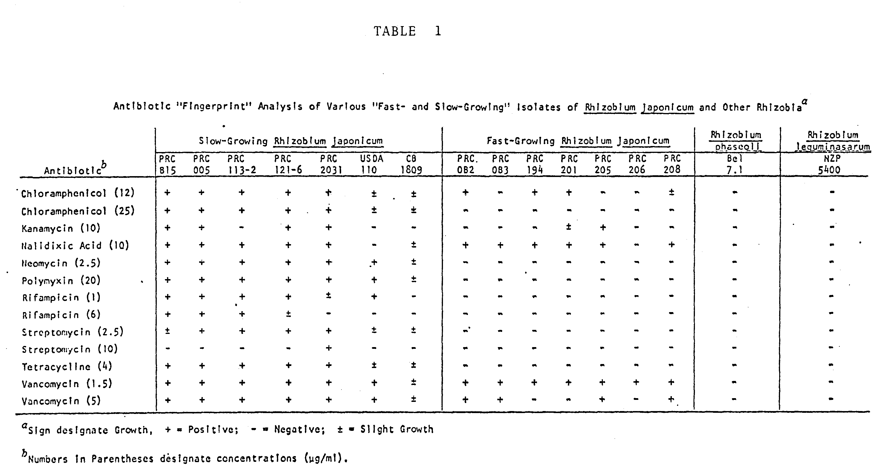
B. ANTIBIOTIC RESISTANT MUTANTS
In the IAR method, very low concentrations of several antibiotics are used to test the intrinsic resistance of the cultures. At higher concentrations of the antibiotics, however, most bacteria become inhibited and only resistant mutants can grow. The use of mutants resistant to very high levels of a few antibiotics, also allows for direct isolation of the organism from soil and rhizosphere. It is important to emphasize, however, that mutants are genetically altered organisms and may not behave the same as the wild-type parent. It is, therefore, necessary to perform several relevant tests to ensure the fidelity of the mutant with respect to the parental attributes.
The antibiotics most commonly used to obtain mutants are streptomycin, spectinomycin and rifampicin (Beringer 1982). The concentrations vary with the antibiotics and the background level of resistance of the strain to the particular antibiotics. In some studies (e.g., Kuykendall and Weber 1978) as high as 500 µg/ml of rifampin and 1000 µg/ml of streptomycin were used to screen for the multiple antibiotic-resistant mutants of R. japonicums, I-110.

Methodology: Spontaneous mutant
To the surface of plates of appropriate agar medium containing inhibitory concentrations of the desired antibiotics, add 10⁸-10⁹ cells from a fresh culture of the organism. Spread the suspension over the surface with a bent glass rod and incubate the plates for several days. The concentration of the antibiotics should be high enough that only a few resistant colonies would develop. The resistant mutants should be purified by successive streaking on selective pa medium, before it is used to develop multiple mutants resistant to other antibiotics.

SELECTED REFERENCES (Antibiotic-Resistance Markers)

Beringer, J. E. 1982. Genetic fingerprinting as a tool in research on biological nitrogen fixation. In "biological Nitrogen Fixation Technology for tropical Agriculture. Papers presented at a workshop held at CIAT, March 9-13, 1981; P. 619-624. Graham, P. H. and Harris, S. C., editors.
Denarie et al. 1976. Effect of some mutations on symbiotic properties of Rhizobium. In "Symbiotic Nitrogen Fixation in Plants;" P. 47-61, Nutman, P., editor.
Josey, D. P. et al. 1979. Strain identification in Rhizobium using intrinsic antibiotic resistance. J. Appl. Bacteriol. 46, 343-350.
Kingsley, M. T. and Bohlool, B. B. 1983. Characterization of Rhizobium spp. (Cicer arietinums L.) by immunofluorescence, immunodiffiusion, and intrinsic antibiotic resistance. Can. J. Microbiol. 29, 518-526.

Kuykendall, L. D. and Weber, D. F. 1978. Genetically marked Rhizobium identifiable as inoculum strain in nodules of soybean plants grown in fields populated with Rhizobium japonicum. Appl. Environ. Microbiol. 36, 915-919.
Pain. A. N. 1979. Symbiotic properties of antibiotic-resistant and auxotrophic mutants of Rhizobium japonicum. J. Appl. Bacteriol. 47, 53-61.
Pankhurst, C. E. 1977. S ymbiotic effectiveness of antibiotic resistant mutants of fast- and slow-growing strain of Rhizobium nodulating Lotus species. Can J. Microbiol. 23, 1026-1033.

III. Bacteriophage Typing for Strain Identification
A. Introduction
B. Isolation of Rhizobiophages from Soil
1. Direct isolation without prior enrichment
2. Enrichment of specific phages
C. Testing Titer of Phage Suspensions
D. Purification
E. Preparation of High-Titered Stocks
F. Storage
G. Typing of Isolates
H. Selected References

By: S. F. Dowdle
B. Ben Bohlool
A. INTRODUCTION
Viruses have been found that can infect nearly every group of microorganisms. Bacteria, fungi, and algae all can serve as host for their own specific viruses. The process of infection has been studied most extensively in bacterial viruses (bacteriophages). Nearly every species of bacterium investigated has been found to serve as host to viruses, but most of the research has been done with those viruses that infect Escherichia coli (Coliphages).
Because the interactions between bacteriophages and their hosts are highly specific, rhizobiophages are of particular interest given their potential importance in exerting selective effects on rhizobial populations.
Although a definitive role for rhizobiophages in the ecology of rhizobia has yet to be fully elucidated, they may be a valuable tool in ecological research of rhizobia. The use of phages in consort with other ecological techniques can increase our ability to differentiate populations of rhizobia. For example, phages have been used to differentiate R. japonicum belonging to the same somatic serogroup. It has been suggested that phages can be used to type nodules, however, the feasibility of such a procedure remains to be demonstrated.
Several procedures for the isolation and preservation of rhizobiophages are described below. The methods are general and should be modified to accommodate particular phage-host combinations.
B. ISOLATION OF RHIZOBIOPHAGES FROM SOIL
Isolation can be accomplished with or without prior enrichment. The necessity for enrichment, and the quantity of soil to be used, will depend on the likelihood of a high concentration of phage for the particular host. Isolation with a prior enrichment in a rhizobial suspension will introduce a selective bias into the sampling. The details of the following procedure will vary depending on the phage and the rhizobia being studied.
1. Isolation without prior enrichment
1) Add 10 g soil to a flask containing 50 mls phage diluting broth, PDB (Vincent 1970). Put on a shaker for 20 min.
2) Centrifuge to remove bulk soil particles (4000 rpm, 20 min.)
3) Collect supernatant and centrifuge to concentrate phage (30,000 rpm, 3 hrs.).
4) Discard supernatant and resuspend pellet in PDB.
5) Add chloroform (0.5 ml/10 mls suspension) to kill bacterial cells. (This can be accomplished by placing on a shaker overnight or by shaking at an elevated temperature (28-32ºC) for several hours).
6) Test the titer of the suspension.
2. Isolation with prior enrichment
1) Inoculate sterile mannitol nitrate, MN (Vincent 1970), broth (50 mls) with desired strain of rhizobium. Flask A.
2) When Flask A is slightly turbid, transfer 1 ml to Flask B.
3) Add 1 gram soil to Flask A. Put on a shaker for 24-48 hrs.
4) When Flask B is slightly turbid, add 1 ml to Flask C.
5) Centrifuge Flask A suspension to remove bulk soil particles and most bacterial cells (4,000 rpm, 20 min.).
6) Add 10 mls of the supernatant to Flask B and place on a shaker for 18-24 hrs. This enrichment process should be repeated for 4 cycles. Do not expect a reduction in turbidity as an indicator of the presence of rhizobiophages.
7) After the final enrichment, the suspension is centrifuged, and the supernatant may be passed through a filter to remove bacterial cells (0.45µm), or chloroform treated as outlined above.
8) Test the titer of the suspension.

C. TESTING THE TITER OF PHAGE SUSPENSION
Several methods are available for plating phages to give isolated plaques. The agar overlay method was chosen because it is simple and reproducible.
1) Prepare MN agar plates. Pour 18-20 mls per 9 cm petri dish and let dry overnight.
2) Concentrated phage suspensions can be tested, or if the concentration is expected to be high, 10 fold serial dilutions can be made in PDB.
3) Take 2 mls of phage suspension and add to molten soft agar tube (4 mls soft agar at 45ºC).
4) Add 0.2 mls of a turbid culture of rhizobia grown in MN broth to the soft agar tube.
5) Mix the phage-rhizobium suspension and with a warm pipette add 2.0 mls of the soft agar suspension to each of two MN agar plates.
6) Allow the soft agar layer to solidify and incubate at 26ºC.

D. PURIFICATION
Isolation plates may contain a mixture of phages so it is recommended to replate at least twice to ensure that a single type is selected.
1) From the primary isolation plate, a well isolated plaque (which, theoretically, should contain progeny from a single phage) is stabbed with a sterile wire, toothpick, or loop. Rinse in about 1 ml of PDB.
2) This suspension, or dilutions of this suspension, are replated using the agar overlay method. Repeat 1 or 2 times.
E. PREPARATION OF HIGH TITERED STOCKS
For small quantities a plate method is preferable to a broth method in that it is less time consuming, and is more likely to yield high titre stocks. A phage-host mixture that gives confluent lysis will result in the highest yields. The precise amount of phage and host to mix will depend on the particular organisms. The researcher will learn this with experience.
1) MN agar plates (25-30 mls/9 cm plate) should be dried thoroughly by incubating for 48 hrs at 37ºC.
2) Phage-rhizobia mixtures are prepared in PDB and 2-3 mls of the suspension is pipetted onto the surface of the MN agar plates. The excess suspension is rapidly decanted.
3) The suspension should be rapidly absorbed. This is best accomplished by inoculating the plates while still warm, and leaving the lids tilted until drying is complete.
4) After incubation, 3 mls of MN broth is added to the plates and let stand for about 20 min at room temperature.
5) Decant the extract carefully.
6) Centrifuge to remove most bacterial cells (5,000 rpm, 20 min).
7) Remaining bacteria may be removed either by chloroform treatment or by filtration.
F. STORAGE
Phages remain viable for long periods of time when stored at 4ºC in nutrient broth. There appears to be no advantage to freezing phage suspensions, and losses on freeze-drying have been reported. Little research work has been done on preservation of rhizobiophages. It is recommended here to store phage suspensions in MN broth in screw-capped vials or test tubes at 4ºC.

G. PHAGE-TYPING OF STRAINS
Phage typing can be a useful tool for differentiating populations of rhizobia. Phage types are established on the basis of phage sensitivity patterns. For the technique to be useful several phages must be available in order to establish meaningful phage sensitivity patterns.

PROCEDURE
1) Prepare overlay agar plates as described.
2) Prepare bacterial suspension and add 0.2 mls to 4 mls of molten soft agar held at 47ºC. Pipett 2.0 mls onto the basal layer. Allow the soft agar to solidify.
3) Each phage suspension should be spotted onto a designated place on each plate. (This can be accomplished by using a grid). For example, if there are 15 phages, each plate will be spotted with 15 different phages. In this way, each plate will reveal the sensitivy of one Rhizobium isolate to 15 different phages. Phages may be spotted onto the plates by using sterile toothpicks or an inoculating needle. Replicates may be spotted on the same plate, on separate plates, or both.

SELECTED REFERENCES
Adams, M. H. 1959. Bacteriophages Interscience Publishers, Inc. New York: N.Y.
Barnet, Y. M. 1980. The effect of Rhizobiophages on populations of Rhizobium trifolii in the root zone of clover plants. Can. J. Microbiol. 26: 572-576.
Billing, E. 1969. Isolation, growth and preservation of bacteriophages. In Methods in Microbiology, J. R. Norris and D. W. Ribbons, eds. Vol 3B, P. 315-329, Academic Press, New York.
Evans, J., Y. M. Barnet and J. M. Vincent. 1979. Effect of bacteriophage on the colonization and nodulation of clover roots by paired strains of Rhizobium trifolii. Can. J. Microbiol. 27, 974-978.
Schwinghamer, E. A. 1965. Host-controlled modification of Rhizobium bacteriophage. Aust. J. Biol. Sci. 18, 333-343.
Staniewski, R. 1970. Typing of Rhizobium by phages. Can. J. Microbiol. 16, 1003-1009.
Vincent, J. M. 1970. A manual for the study of root-nodule bacteria. IBP Handbook No. 15. Blackwell Scientific Publications, Oxford and Edinburgh.

