6. METHODS OF INOCULATION

To form an inoculant, laboratory-grown cultures of rhizobia are mixed with various inert, finely pulverized solids, such as peat, compost, filter mud, bagasse or some other suitable carrier. This formulation is usually applied to legume seeds before planting to make certain that effective nodules will develop and that the plants will have a dependable supply of nitrogen. An alternative method is to apply the inoculant directly to the soil. This is necessary under some conditions although it may be more expensive.
With seed, the inoculant rate recommended by manufacturers ranges from 4 to 6 grams per kilogram of seed or

32

Figure 11. Model experimental design for legume inoculation trial

0.28 to 0.42 kilograms per hectare at the usual seeding rate of cowpeas (Vigna unguiculata) or soybeans (Glycine max). By comparison, 6 to 8 kilograms of soil granular inoculant are required per hectare of land.

33
Table 4. EXPLANATIONS FOR FIELD SITUATIONS FOUND
IN INOCULATION TRIALS
 | Situation | Explanation
Non-inoculated plants
1. | No nodules on non-inocu- | No native rhizobia capable of
 | lated control. Plants yellow. | infecting that legume.
2. | Many small nodules scat- | Native rhizobia are ineffective
 | tered over root system. | in fixing nitrogen.
 | Plants yellow.
3. | No nodules on non-inocu- | Soil high in mineral nitrogen.
 | lated control. Plants green. | No native rhizobia capable of
 |  | nodulating that legume.
4. | Small nodules on non-inocu- | Soil high in mineral nitrogen.
 | lated control. Plants deep | Native rhizobia may be effec-
 | green. | tive or ineffective.
5. | Non-inoculated control plants | Native rhizobia infective and
 | have numerous large nodules. | effective. Inoculation not
 | Plants deep green colour. | necessary.
Inoculated plants
6. | Nitrogen control - nodu- | Infective rhizobia. Nodules not
 | lated - nodules small, | active because of nitrogen level.
 | plants green.
7. | Inoculated plants have no | Improper inoculum or rhizobia
 | nodules. Plants yellow. | in inoculum dead.
8. | Inoculated plants have small | Soil high in mineral nitrogen.
 | nodules and deep green col- | Nodules not operating.
 | our.
9. | Inoculated plants have large | Native rhizobia ineffective. In-
 | nodules, red on the inside. | oculant highly effective.
 | Plants deep green. Non-inoc-
 | ulated control has small nod-
 | ules or no nodules and yellow
 | colour.
10. | Inoculated + nitrogen-plants | Rhizobia not adequate. Need
 | larger and greener than those | more effective strains.
 | receiving only inoculant. Nod-
 | ules small to medium.
11. | Inoculated plants receiving | Soil low in phosphorus and po-
 | phosphorus and potassium - | tassium. Needs fertilizer for maxi-
 | larger, more vigorous than | mum nitrogen fixation.
 | non-fertilized plants from
 | inoculated seed.

34
Seed inoculation

Forms of seed inoculants

The forms of seed inoculants currently available are:

(a) Agar slants in bottles
(b) Peat, compost, coal, vermiculite, and other solid-
based moist powders
(c) Broth or liquid cultures
(d) Lyophilized or freeze-dried preparations (e) Frozen concentrates of broth
(f) Oil-dried preparations on talc or vermiculite
(g) Rhizobia entrapped in polyacrylamides, alginates or
xanthanes

Methods of applying seed inoculants

Slurry. In the slurry method (Fig. 12), the inoculant is first mixed with water to form a uniform, pourable suspension. In some instances, gums or sugar may be added to the water to improve adhesion of the inoculant to the seed. The use of sugar in the inoculant slurry decreases the death rate of rhizobia on the drying seed.
The amount of water needed in the slurry varies with different seeds. More water is needed for small seeds than for large seeds because of the greater surface area to be coated. It is very important not to get the seed too wet because seeds may stick together or be damaged by the seed drill. The seeds should be thoroughly coated with the inoculant particles (Fig. 13).
The amounts of water needed to inoculate various kinds of seed are given in Table 5.

Seed hopper - dry method. In this method, the inoculant powder is mixed directly with seed without using any water or other liquid. Because the dry inoculant does not adhere well to the seed and is lost, it is generally unsatisfactory

35
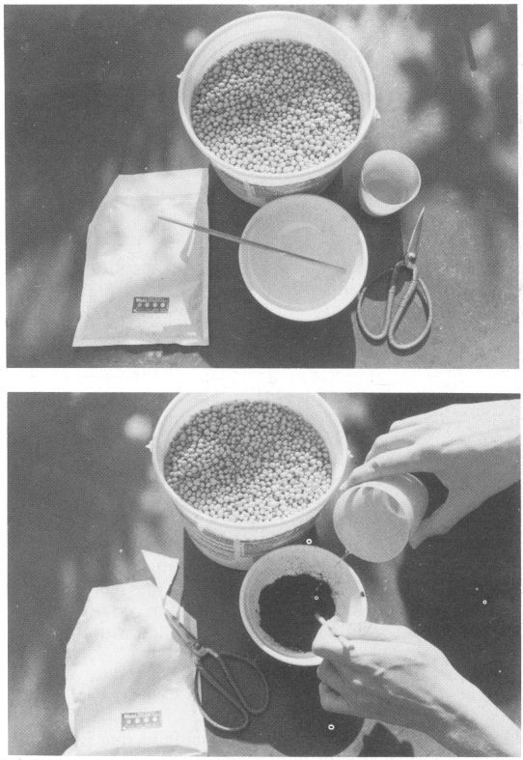
Figure 12. Seed inoculation by slurry method: (a) view of equipment, (6~ addition of water to peat-base inoculant

36
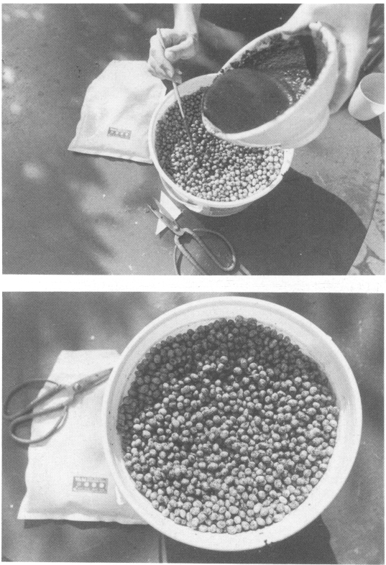
Figure 12. (c) mixing of slurry with seed, (d) seed coated with dried inoculant

37
Table 5. AMOUNTS OF INOCULANT AND WATER
REQUIRED FOR SLURRY INOCULATION
OF LEGUME SEEDS OF VARIOUS SIZES
Legume  species | Seeds  (no./kg)¹ | Inoculant  (g/25 kg of seed) | Water  (ml/25 kg  of seed) | Slurry  (ml/25 kg of seed)
Trt olium repens  white clover) | 2 000 000 | 110 | 625 | 750
Medicago sativa  (alfalfa) | 500 000 | 110 | 550 | 650
Coronilla varia  (crown vetch) | 250 000 | 110 | 550 | 650
Vigna radiata  (green gram) | 25 000 | 110 | 500 | 550
Vigna unguiculata  (cowpea) | 10 000 | 110 | 375 | 437
Glycine max  (soybean) | 5 000 | 110 | 250 | 287
Cicerarietinum  (chick-pea) | 2 000 | 110 | 250 | 287
Vicia faba  (broad bean) | 1 250 | 110 | 175 | 200

Note: Legumes are arranged in ascending order of seed size. Approximate values.

38
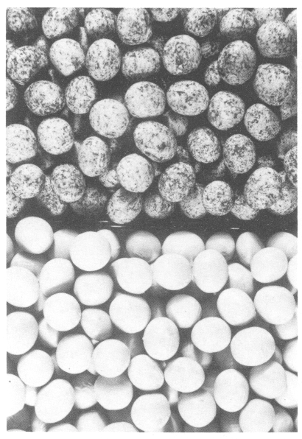
Figure 13. Soybean (Glycine max) seeds: slurry inoculated on top. non-inoculutccl on bottom
and is not recommended. Its only advantage is that it is easy.

Lime pellet. Rhizobia die on inoculated seed when the seeds are planted in highly acid soil or when the seeds are mixed with acid fertilizers prior to sowing. In order to avoid this, legume seeds are lime-pelleted. First, the seeds are inoculated by wetting them thoroughly with a peat-base inoculant slurry. Then they are quickly mixed and rolled in a finely pulverized limestone until they are thoroughly

39
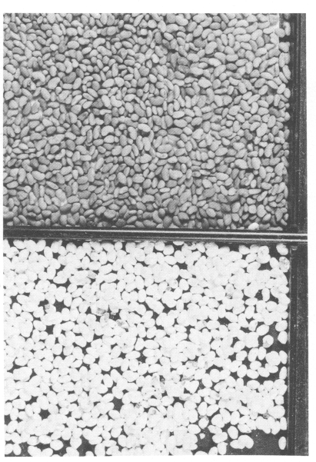
Figure 14.
Lucerne
(Medicago
sativa)
seeds: non-
inoculated on
top, lime coated
on bottom
coated with the limestone particles (Fig. 14). Under tropical conditions, powdered, rock phosphate is often substituted for the limestone because limestone can be harmful to acid-tolerant rhizobia. The particulate matter limestone and/or pulverized rock phosphate serves to dry the seeds and keep them from adhering to each other.
The inoculant slurry should be made with an adhesive, either gum arabic or a synthetic cellulosic gum, to bind the lime coating firmly to the seeds. The gum solution for making the slurry should be moderately viscous but flow easily.

40
The proper amounts of inoculant, water, slurry and powdered limestone required for various legume seeds are given in Table 6.
There are some disadvantages to pelleting: the weight of seed is increased substantially, coated seeds are very abrasive and may damage the drill, and special machinery is needed to mix the wet seed with the powdered limestone or phosphate. Also, it is difficult to coat seeds uniformly. The seed/limestone ratio may vary widely and result in irregular seeding rates.

Inoculant pellet. A modified pelleting system in which the seed is coated with peat-base inoculant can be used when a very large Rhizobium inoculum is required. One third of the inoculum (4 g/kg seed) is applied to the seed as a gum arabic slurry. The remaining two thirds of the inoculum (8.5 g/kg seed) are mixed immediately with the wet seed. This serves to coat and dry the seed. This system of inoculating has proved very successful for seeds planted in hot, dry soils or where soils are heavily infested with native ineffective rhizobia.

Coated seed. In pelleting legume seeds with pulverized limestone, rock phosphate or peat-base inoculant, watersoluble gums are used. With these vegetable gums, the pelleting materials tend to flake off, particularly when the seed is inoculated several weeks in advance. To overcome this, various water-insoluble adhesives such as polyvinyl acetate, polyvinyl alcohol, polyurethane, polyurea varnishes or resins are dissolved in solvents and used to bond the particulate substances - charcoal, clay, diatomaceous earth, talc and other substances-to the seed. Peat-base inocula, seed chemicals and micronutrients may also be included in the mix. The seed coating is usually done by seed processors before the seeds are offered for sale. Usually it is not practicable to do the seed coating on the farm.
Some of the advantages claimed for coated seed are: more uniform seeding, easier planting, better germination,

41
Table 6. AMOUNTS OF INOCULANT, WATER, SLURRY,
AND POWDERED LIMESTONE REQUIRED TO PELLET
LEGUME SEEDS OF VARIOUS SIZES
Legume  species | Seeds  (no./kg) | Water  (ml/25 kg  of seed) | Slurry  (ml/25 kg  of seed) | Limestone  (ml/25 kg  of seed)
Trifolium repens  white clover) | 2 000 000 | 1 050 | 1 175 | 10
Medicago saliva  (alfalfa) | 500 000 | 1 050 | 1 175 | 10
Coronilla varia  (crown vetch) | 250 000 | 1 050 | 1 175 | 10
Vigna radiata  (green gram) | 25 000 | 950 | 1 000 | 8.7
Vigna unguiculata  (cowpea) | 10 000 | 425 | 500 | 5
Glycine max  (soybean) | 5 000 | 425 | 500 | 5
Cicer arietinum  (chick-pea) | 2 000 | 400 | 475 | 5
Vicia faba  (broad bean) | 1 250 | 375 | 425 | 5

Note: The inoculum is used at a rate of 250 grams per 25 kilograms seed, which is approximately twice the normal rate.

42
stronger and healthier seedlings, early modulation, better nourished seedlings and so on. However, the beneficial effects of these coatings have not been proved. Further, solvent-based adhesives are often toxic to the rhizobia. With a very large peat-base inoculum, some rhizobia may survive for a few weeks, but prospects for effective modulation under most field conditions are poor.

Pre-inoculated seed. Pre-inoculated seed is seed inoculated before being offered for sale. The inoculation is usually done by seed processing companies months in advance of planting. While this idea is attractive to farmers, results have been very disappointing. The legume seed does not provide a good habitat for rhizobia; the death rate is rapid. A peat-base inoculum applied as a coating with gums and sugars has assured better survival than other systems, but results with pre-inoculated seed have not been dependable.

Soil inoculation

Necessity

Soil inoculants are those designed for application directly to the soil rather than to the seed (Fig. 15). This type of inoculation is recommended under the following conditions:

(a) When the leguminous seeds are coated with toxic
chemicals for protection against fungi, insects or other
soil pests and rhizobia applied to seeds would be killed.
(b) When planting in hot, dry soils is unavoidable. Placing
rhizobia in moist soil below the seeds can result in good
survival and effective modulation.
(c) When soils are heavily infested with large populations of infective non-nitrogen-fixing strains. Soil inoculants can introduce a larger inoculum of effective rhizobia than can be applied directly to the seed.

43
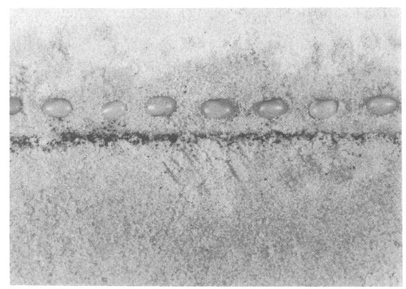
Figure 15. Soil inoculation. Side view showing layer of inoculant granules placed below the seed (bean, Phaseolus vulgaris)

(d) When good stands of legumes are obtained initially but for some reason the plants fail to develop nodules. Soil inoculants can be drilled into the ground after planting using sod-type seeders, or broadcast or sprayed on the surface soil just before rain or irrigation. This emergency inoculation practice can bring about effective modulation and save the stand.

Forms of soil inoculants

The forms of soil inoculants vary widely, depending upon the preferred method of application. The various types of soil inoculant are:

Liquid or frozen concentrates. In the Netherlands, these
have been distributed successfully for many years using drip

44
or spray systems. Effective inoculation of soybeans was obtained in the Casamance area of Senegal by applying 5 litres of a slurry (2/3 peat and 1/3 water) per hectare. In Australia, good results are obtained by mixing the regular peat-based seed inoculant with water and pumping the resulting suspension into the seed furrow using a drillmounted pumping unit.

Inoculated granule. Small marble, calcite or silica grains or cores are wetted with a good adhesive and inoculated with a powder-type (usually peat-base) inoculum. After drying, the granules are distributed by broadcasting, using a whirlwind-type spreader. The dense granules are very suitable for gravity distribution either on the surface or from the air.
Granular inoculants are prepared in New Zealand by binding a finely, pulverized peat inoculant to coarse sand using an adhesive. This inoculant is broadcast over the soil surface or applied with a drill attachment for granular products.
Granular soil inoculants, designed for distribution through drill applicators built for insecticide application, are of more recent origin. These enable uniform distribution of a relatively small amount of inoculant, 6 to 8 kilograms per hectare.

Natural peat granule. This form of inoculant "Implant" is prepared by adding Rhizobium broth culture to natural sedge peat granules ranging from 300 to 800 [tm in diameter. Sufficient moisture (32 to 35 percent) is added to permit growth and multiplication of the rhizobia in the granules. The inoculant flows easily and can be distributed uniformly using a granular applicator drill attachment.

Porous gypsum granule. This granule is prepared by extruding calcium sulphate paste through small circular openings and segmenting with a knife to obtain the desired length. The gypsum granules are made in different sizes to

45
correspond with seed size. After drying, the gypsum granules are sprayed with a broth culture of rhizobia mixed with 12.5 percent milk powder and an equal volume of saturated sucrose solution. The gypsum granules are then ready to be mixed and distributed simultaneously with the seed.

Other granules. In France, three inoculants - a polyacrylamide (PER),.an alginate (AER) and an xanthan/ carob gum (XER) inoculant - have been used successfully in inoculating soybeans grown in soil free of Rhizobium japonicum. In trials, the semi-dried XER form produced the best results. Application rates varied from 26 to 54 kilograms per hectare; only the high rate produced a significant increase in yield over the seed-applied inoculant.

