MEALANI RESEARCH STATION

ENVIRONMENTAL CONDITIONS:
Elevation: 2,800 feet
Temperature range: 55-69 ºF
Annual rainfall: 58.4 inches

SOIL CHARACTERISTICS:
Soil Series: Maile/MLD
pH: 5.8 (OK)
Phosphorus: 27 ppm (sufficient)
Potassium: 140 ppm (low)
Calcium: 2,400 ppm (high)
Magnesium: 120 ppm (very low)

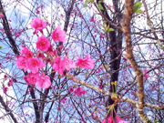
Turf Garden Layout

Honokaa
 |  | 16 |  | 8  Zoysia or Manila  Z-3
 |  | 15  Buffalo  609 |  | 7  Green Velvet
 |  | 14  Seashore paspalum  Tropic Shore |  | 6  Hybrid bermuda  Tifdwarf
 |  | 13  St. Augustine  Floratine |  | 5  Hybrid bermuda  Tifway 419I
 |  | 12  St. Augustine  Seville |  | 4  Buffalo  Highlight 912
18  Turf blend |  | 11  Zoysia  Sugi |  | 3  St. Augustine, varigated
17  Bent |  | 10  Zoysia or Manila  Emerald |  | 2  Seashore Paspalum
16  Kentucky Blue x Fescue |  | 9  Zoysia or Japanese  El Toro |  | 1  Hybrid bermuda  Sunturf

Grasses are listed by common name and variety name. Established in the Spring of 1997.
Contact: Glen K. Fukumoto, Cooperative Extension Service - Kona - 322-4892
Milton Yamasaki, Mealani Research Station - 887-6185.

Turf Grass Collection by Botanical Name.

- Cynodon magennisii
- Paspalum vaginatum
- Stenotaphrum secundatum
- Buchloe dactyloides
- Cynodon dactylon x C. transvaalensis
- Cynodon dactylon x C. transvaalensis
- Green velvet
- Zoysia matrella
- Zoysia japonica
- Zoysia matrella x Z. tenuifolia
- Zoysia sp.
- Stenotaphrum secundatum
- Stenotaphrum secundatum
- Paspalum vaginatum
- Buchloe dactyloides
- Kentucky blue x Fescue
- Bent
- Turf blend


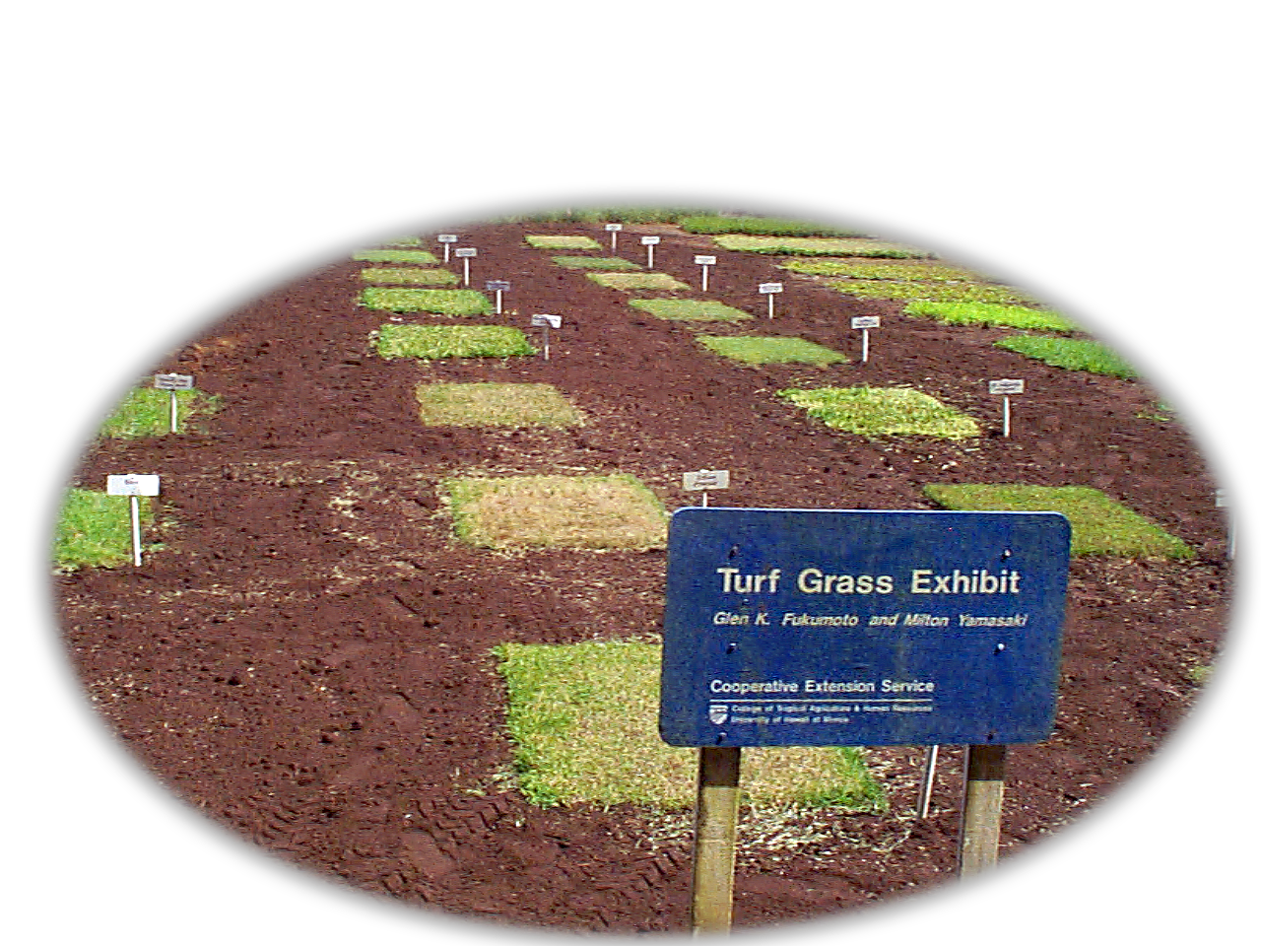
Turf
Grass
Garden

Glen Fukumoto & Milton Yamasaki
Mealani Research Station
Kamuela, HI 96743

