FIELD CORN SYNTHETICS AND COMPOSITES
Hawaii Foundation Seeds

1. SYNTHETICS (Inbred-based)

HIS1k (PI652869) Selected for resistance to northern leaf blight, Exserohilum (i.e., Helminthosporim) turcicum, based on14 inbreds (formerly MIRSYN1)
HIS2f (PI652870) Selected for high yield GCA, based on 18 inbreds of both tropical and temperate origin; ~50% temperate (formerly MIRSYN2)
HIS3k (PI652871) Selected for superior resistance to southern leaf rust, Puccinia polysora, based on 22 inbreds (formerly MIRSYN3); See photo below
HIS4i (PI652872) Selected for resistance to common rust, Puccinia sorghi, based on 19 inbreds (formerly MIRSYN4)
HIS5f (PI652873) Selected for tolerance of southern leaf blight, Cochliobolous heterostrophus (formerly Bipolaris maydis, based on 14 inbreds (formerly MIRSYN5)
HIS6d (PI652874) Synthetic for high grain yield, based on 38 outstanding inbreds of tropical origin with broad range of tolerances to insects and diseases.
HIS7c Synthetic based on brown-midrib 2 inbreds and conversions

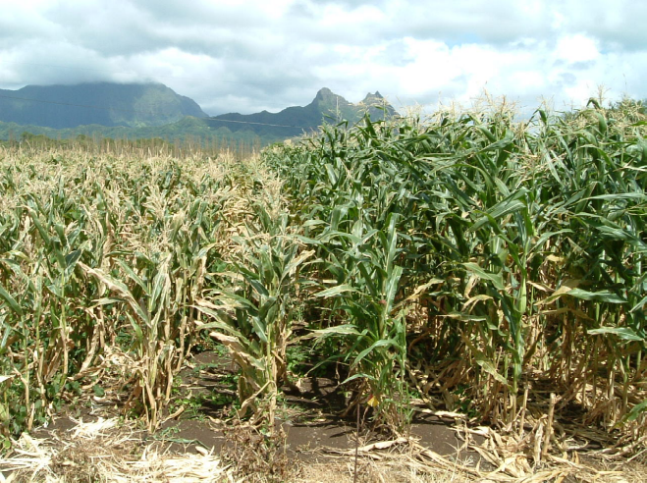

2. COMPOSITES (Open-pollinated populations or “OP varieties”)
HIC1p (PI652866) Composite based on opaque 2 (high lysine), W/Y, denty, lines derived from Tuxpeño x Corn Belt
HIC2e (PI652867) Composite; D/F, W/Y, based on backcrosses of Zea diploperennis (25%) and 10 elite UH inbreds HI26 to Hi35 (75%) (Originally named HIC9)
HIC3aa (PI652868) Kalakoa, a flinty composite bred for Indian-corn variability in color of ears and plants, based on p-vv stock of Dr. H. E. Brewbaker x tropical flints (Was “HIC10”)
Note: Letter indicates cycle of selection (e.g., >y= represents 24 cycles)
Y = yellow kernels; W = white kernels; D = dent kernels; F = Flint kernels

COMPONENT INBREDS OF HAWAII SYNTHETICS

Synthetic, Objective. Component Inbreds

HIS 1 Northern Leaf Blight (Exserohilum turcicum)
B77, CM103, CIMMYT-T11ES, H95, Kenya F, Hi28, Hi34, ICA L29, ICA L36, ICA L210, ICA L219, ICA L221, INV 534, SC (=SR52M)
HIS 2 High Yield, Temperate x Tropical (As assessed by GCA in hybrids)
B73, B77, CI66, CIMMYT-A21, CIMMYT-T11E.S., CM103, H55, Hi26, Hi28, Hi29, Hi31, Hi33, Hi34, ICA L210, ICA L221, INV 534, Ky226, Tx601
HIS 3 Southern Rust (Puccinia polysora)
CIMMYT-T11ES, Fla2AT115, Hi34, INV 138, ICA L210, ICA L219, ICA L221, ICAL223, INV 138, INV 302, INV 534, ICA L223, INV 302, Ki9, Narino 330-S6, MIT2-S6, SC55,TZi7, TZi11, TZi12, TZi14, TZi30
HIS 4 Common Rust (Puccinia sorghi)
B84, CIMMYT-T11ES, CM118, H55, H98, Kenya F, Kenya G, Hi28, Hi32, Hi33, Hi34,
HIX4267, ICA L27, ICA L219, ICA L223, Ki9, Ki14, Narino 330-S6, Oh43
HIS 5 Southern Leaf Blight (Cochliobolus heterostrophus)
Fla2AT114, Fla2AT115, Fla2AT116, Fla2BT73, Fla2BT106, Hi35, Hi39, Ki9, Ki14, ICAL221, INV 534, TZi3, TZi5, TZi11
HIS 6 High Grain Yield, Tropical
Hi26, Hi28, Hi34, Hi41, Hi42, Hi43, Hi44, Hi45, Hi46, Hi47, Hi49, Hi50, Hi51, Hi52, Hi53, Hi54, Hi56, Hi57, Hi58, Hi59, Hi60, Hi61, Hi62, Hi63, Hi64, Hi65, Hi66, Hi67, Hi68, ScFW1, ScFW6, ScMF6, ScZH1, KS23-3, KS23-4, KS23-5, CML223, CML295

Note re Breeding History: All advanced generation breeding was done in Hawaii, with its recognized subtropical ecosystem. High selection pressure existed for resistance to fusarium rots and maize mosaic virus, for which all are highly tolerant. Other factors include low light (short winter days), high populations of earworms, aphids, thrips, leafhoppers. Common diseases also included maize chlorotic mottle virus, bacterial leaf blights and southern rust.

Publication: These syns and comps are described in detail in J. Plant Registration 3:10-13, 2009.

(hfsweb\fieldsyns&comps.doc)

