
Produce An Athlete Website Evaluation
http://www.ctahr.hawaii.edu/paa

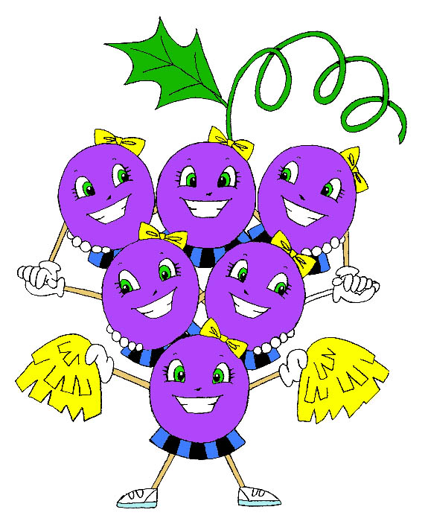
The Produce An Athlete project needs your help! If you visited our website, please answer this survey and put it in the mail. We value your feedback! The first 100 individuals to respond will receive a special thank you gift in the mail.

Which website elements did you find useful?
- Newsletters
- Fluids
- Washing Hands
- Fruits and Vegetables
- Snack suggestions
- Potluck suggestions
- Helpful Links for parents
- Healthy Interactive Links for kids

List the recipes from the website that you have made or plan to prepare:

Please respond to the following about your child/children participating in sports/ physical activity:
Washing or sanitizing their hands after practice and games before eating:
- My child/children always do this.
- My child/children are doing this more often since visiting the website.
- My child/children should be doing this.
Water/fluids during and after practice and games:
- My child/children were already drinking an adequate amount of water/fluids.
- My child/children are drinking more water/fluids since visiting the website.
- My child/children still need to drink more water.
They are drinking:
Fruits and vegetables:
- My child/children were already eating enough fruits and vegetables.
- My child/children are eating more fruits and vegetables since visiting the website.
- My child/children should be eating more fruits and vegetables.

What types of snacks are they eating after practice and games? ____________________________________________________________________________________

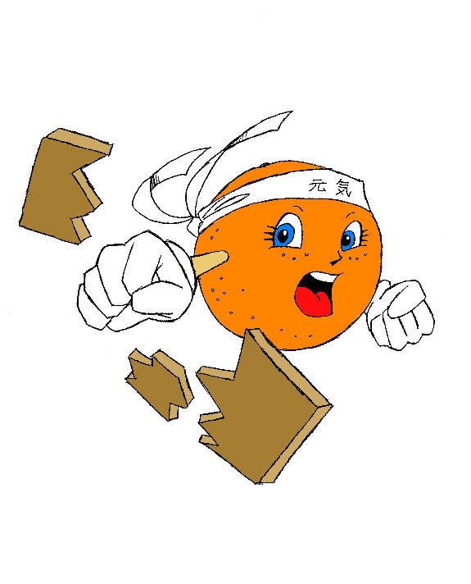
How easy was it to navigate and use the site?
- Very easy
- OK
- Not user-friendly

Would you tell a friend or relative about this website?
- No
- Yes

Additional comments: ___________________

*Name & Mailing Address: _______________________________
__________________________________
_________________________________________ *Needed to receive gift.

Mahalo, Produce An Athlete Project, University of Hawaii at Manoa, Cooperative Extension Service
MAIL SURVEY TO: PAA, 1955 East West Rd. #217, Honolulu, HI 96822

